Project 1: Automate PNG Transfer Between S3 Buckets Using AWS Lambda

# 🎯 Objective

Create a serverless automation using AWS Lambda that triggers on file upload to 'bucket1', filters for '.png' files, and copies them to a designated folder in 'bucket2'. This should include error handling.

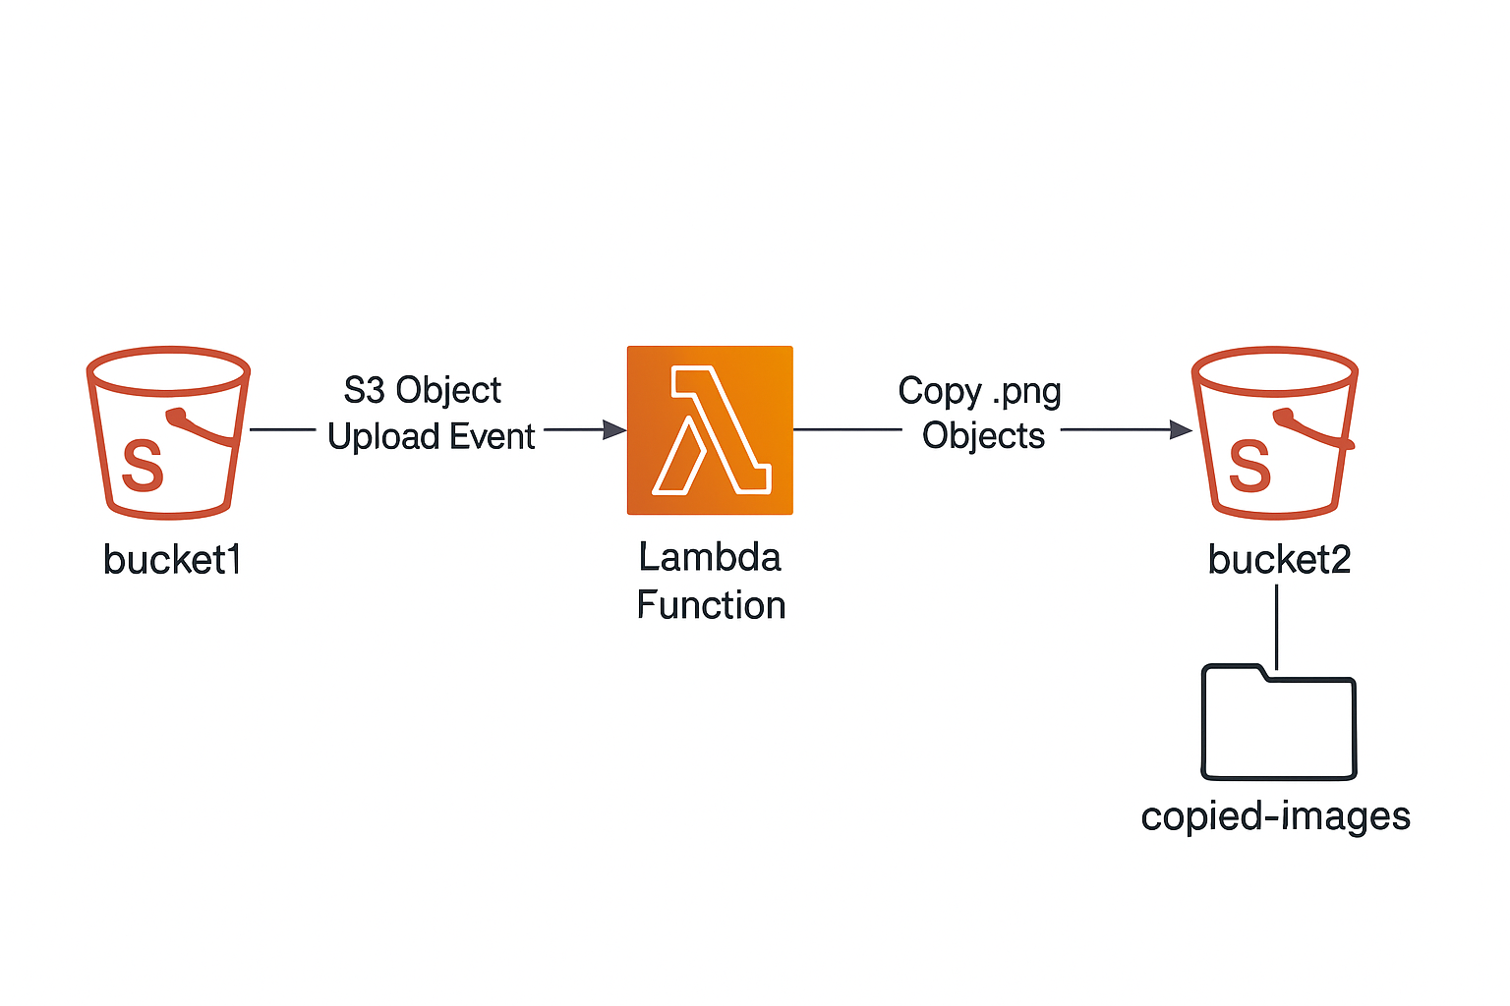

# ✅ Step-by-Step Instructions

## Step 1: Create Two S3 Buckets

* Go to the AWS S3 console.
* Create two buckets:
* - bucket1 – source bucket
* - bucket2 – destination bucket
* Keep them in the same region to avoid cross-region costs or permissions complexity.
* 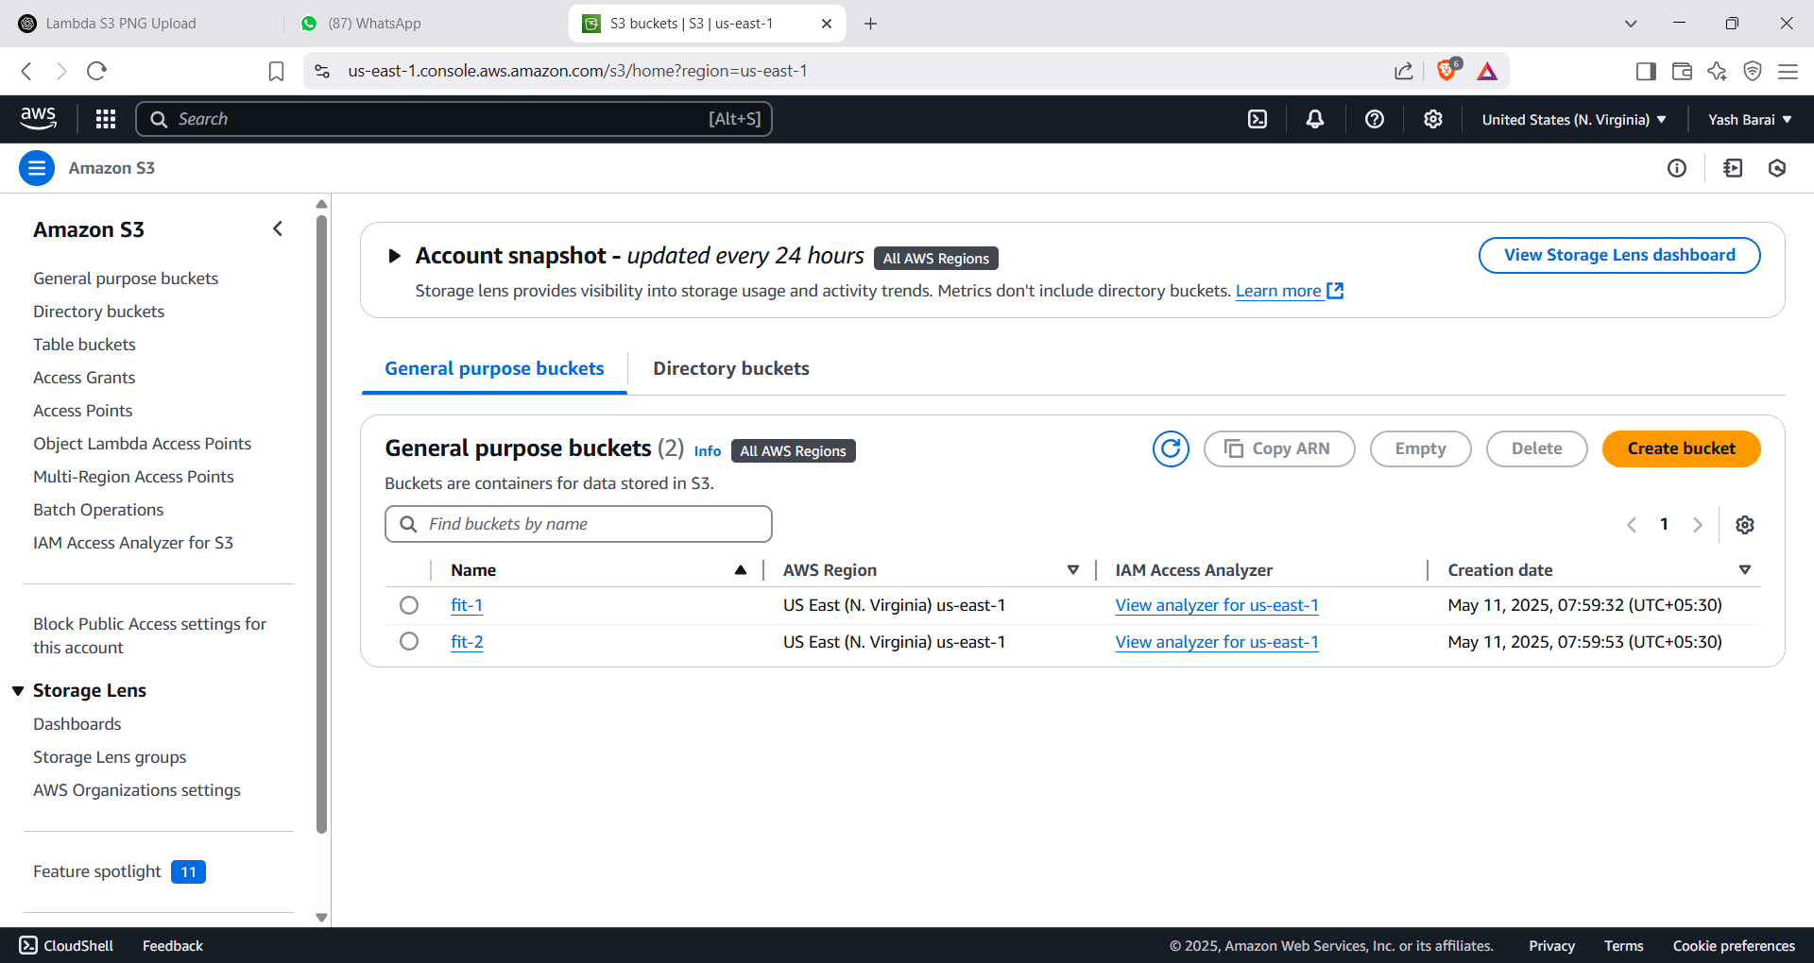

## Step 2: Create the Lambda Function

* Go to the AWS Lambda console.
* Click “Create function”.
* Choose 'Author from scratch', give a name (e.g., CopyPNGtoBucket2), choose Python 3.12
* Create a new role with basic Lambda permissions.
* Click 'Create Function'.
* 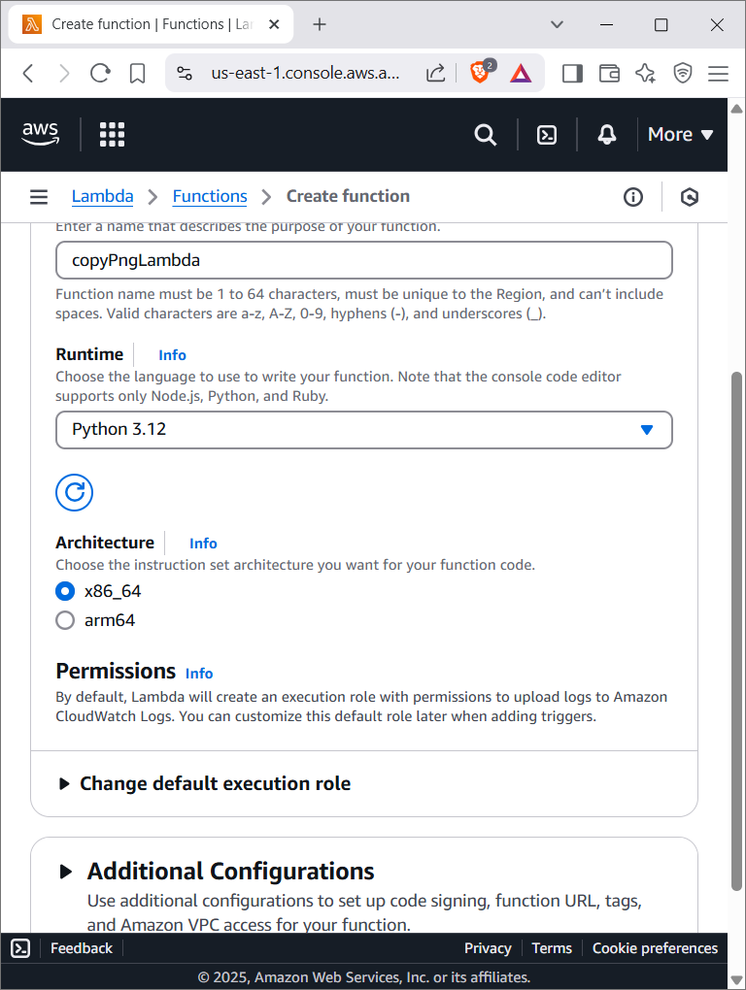

## Step 3: Add S3 Trigger to Lambda

* In Lambda's 'Designer' section, click '+ Add trigger'.
* Select S3, choose 'bucket1', set event type to 'PUT'.
* Enable the trigger.
* 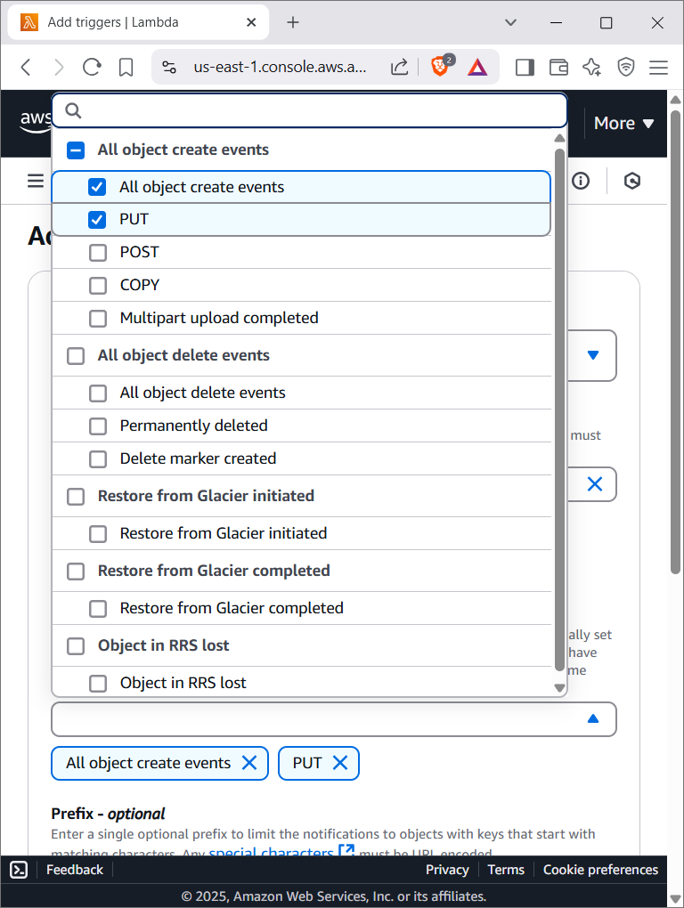
* You should choose only put here

## Step 4: Update IAM Role Permissions

* Go to IAM → Roles → [Your Lambda Role] → Add permissions.
* Attach the following inline policy:
* {  
   "Version": "2012-10-17",  
   "Statement": [  
   {  
   "Effect": "Allow",  
   "Action": ["s3:GetObject"],  
   "Resource": "arn:aws:s3:::bucket1/*"  
   },  
   {  
   "Effect": "Allow",  
   "Action": ["s3:PutObject"],  
   "Resource": "arn:aws:s3:::bucket2/*"  
   }  
   ]  
  }

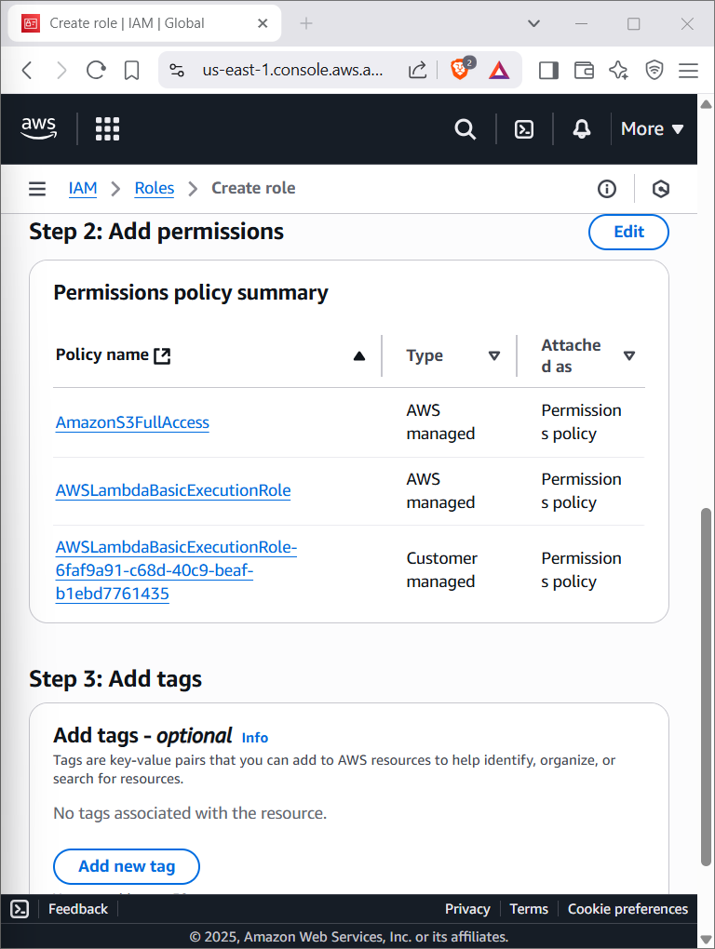

## Step 5: Lambda Function Code

* Paste this code in the Lambda editor:

import boto3

import urllib.parse

s3 = boto3.client('s3')

def lambda_handler(event, context):

try:

source_bucket = event['Records'][0]['s3']['bucket']['name']

key = urllib.parse.unquote_plus(event['Records'][0]['s3']['object']['key'])

if not key.lower().endswith('.png'):

print(f"Not a PNG file: {key}")

return

destination_bucket = 'bucket2-yourname'

destination_key = f"copied-images/{key.split('/')[-1]}"

s3.copy_object(

CopySource={'Bucket': source_bucket, 'Key': key},

Bucket=destination_bucket,

Key=destination_key

)

print(f"Copied {key} to {destination_bucket}/{destination_key}")

except Exception as e:

print(f"Error copying {key}: {e}")

raise e

* 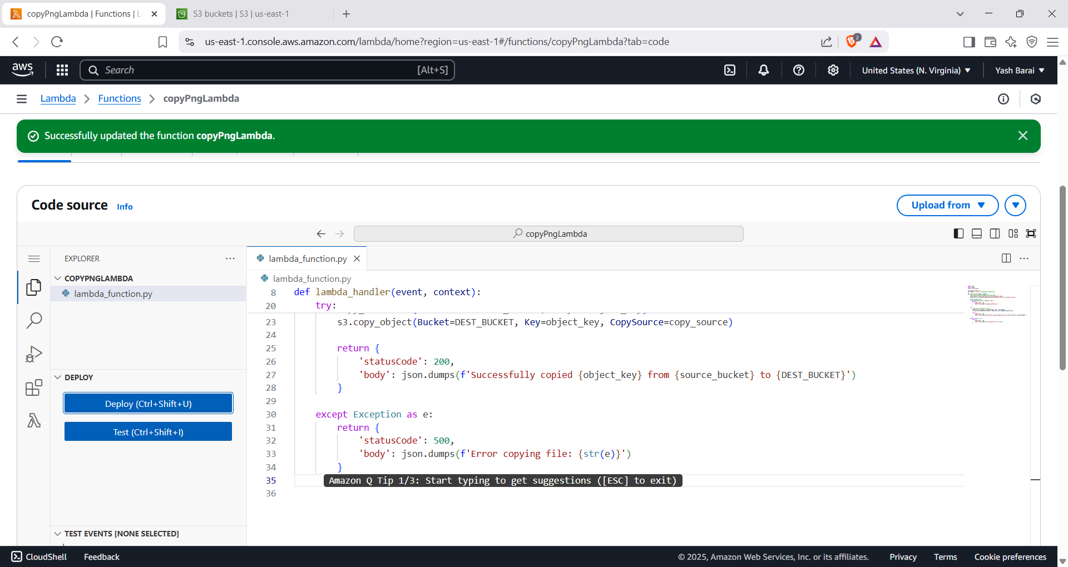

## Step 6: Test the Setup

* Upload a '.png' file to 'bucket1'.
* Check 'bucket2/copied-images/' for the file.
* Verify non-PNG files are ignored.
* 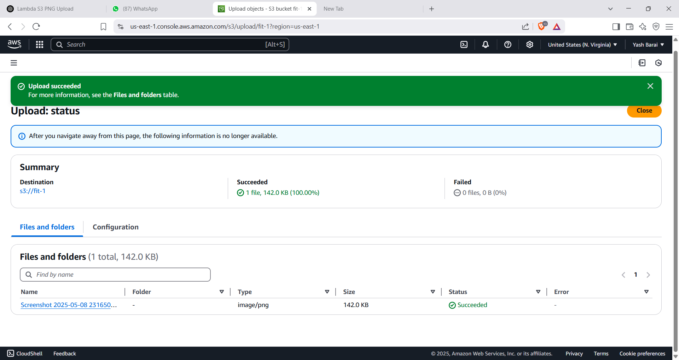

Successfully image is getcopied in fit-2

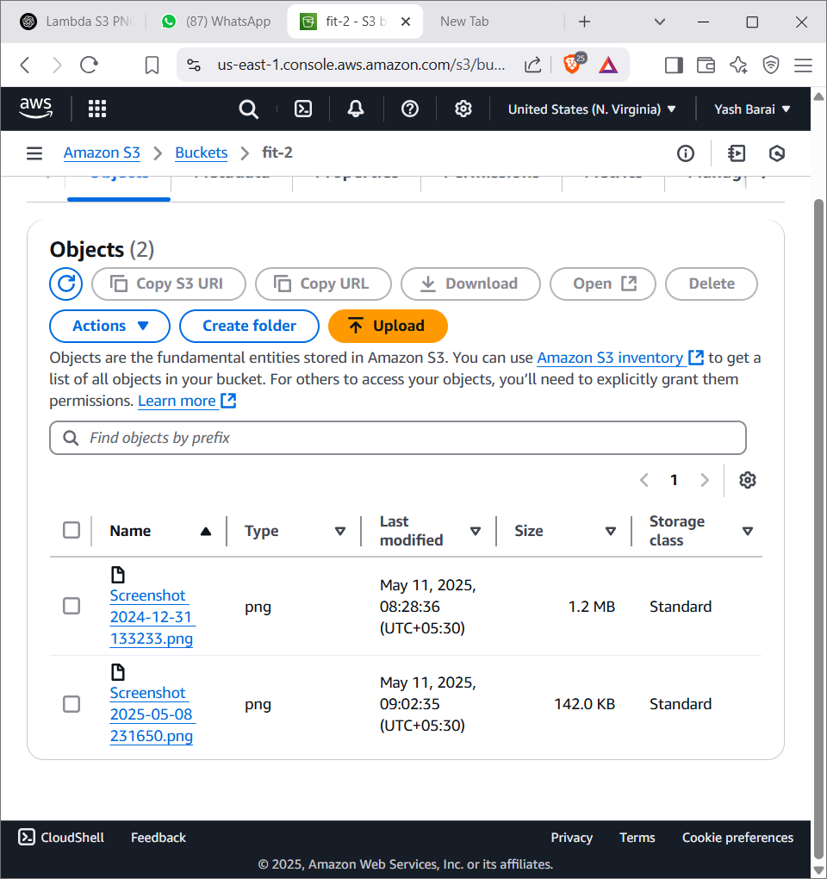

* **Project2: Serverless Contact Form with API Gateway + Lambda + S3**
* **Goal**: Create a **contact form** (HTML) that submits data to an **API Gateway endpoint**. The API triggers a **Lambda function**, which stores the data into an **S3 bucket** as a .json file.
* **✅ Step-by-Step Guide**
* **Step 1: Create an S3 Bucket**

1. Open **S3** > Click **"Create bucket"**.
2. Bucket name: contact-form-submission-0911
3. Keep default settings (Block all public access ON is okay).
4. Click **Create bucket**.

* 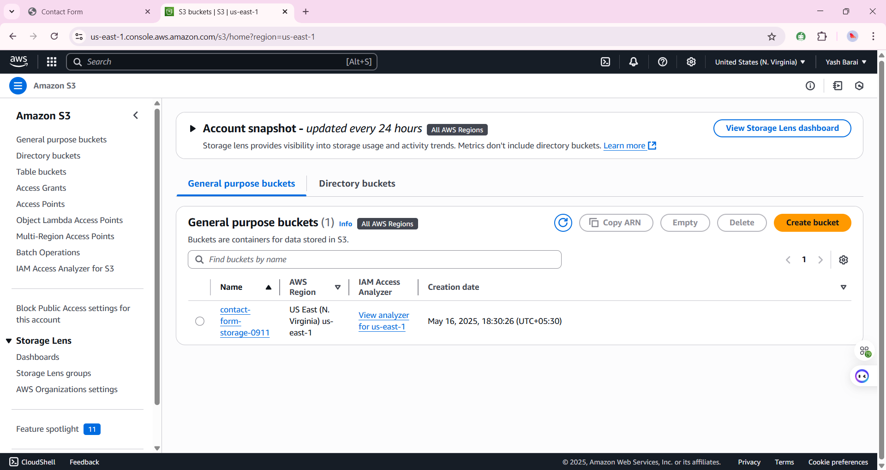
* **Step 2: Create a Lambda Function**

1. Go to **Lambda** > **Create function**.
2. Function name: storeContactFormData
3. Runtime: Python 3.12
4. Click **Create function**
5. 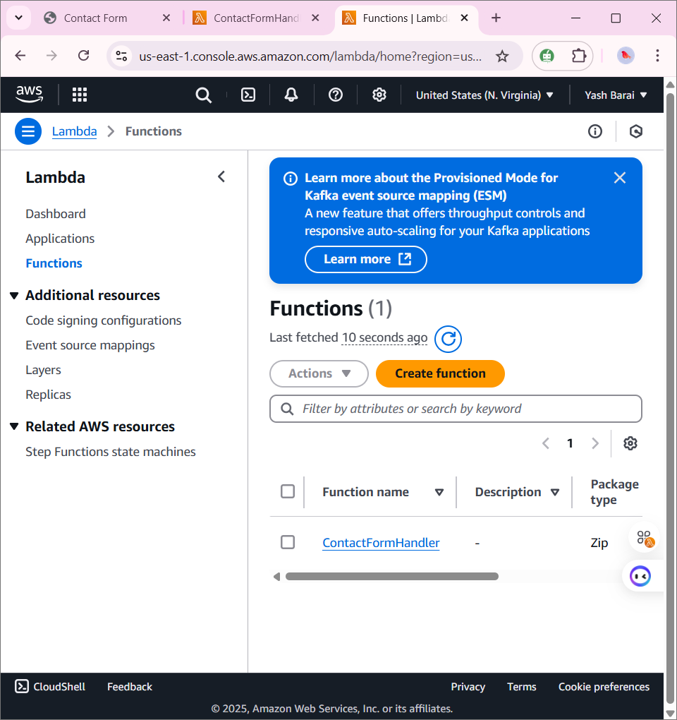

* **Step 3: Add Lambda Code**
* Paste this code:
* Node.js
* Copy code
* const AWS = require('aws-sdk');
* const s3 = new AWS.S3();
* const BUCKET_NAME = 'contact-form-storage-0911';
* exports.handler = async (event) => {
* console.log('Received event:', JSON.stringify(event));
* const body = JSON.parse(event.body);
* const timestamp = new Date().toISOString();
* const data = {
* name: body.name,
* email: body.email,
* message: body.message,
* timestamp,
* };
* const params = {
* Bucket: BUCKET_NAME,
* Key: `contact-form-${timestamp}.json`,
* Body: JSON.stringify(data),
* ContentType: 'application/json',
* };
* try {
* await s3.putObject(params).promise();
* return {
* statusCode: 200,
* body: JSON.stringify({ message: 'Form data saved successfully!' }),
* };
* } catch (err) {
* console.error('Error saving data:', err);
* return {
* statusCode: 500,
* body: JSON.stringify({ message: 'Failed to save form data' }),
* };
* }
* };
* 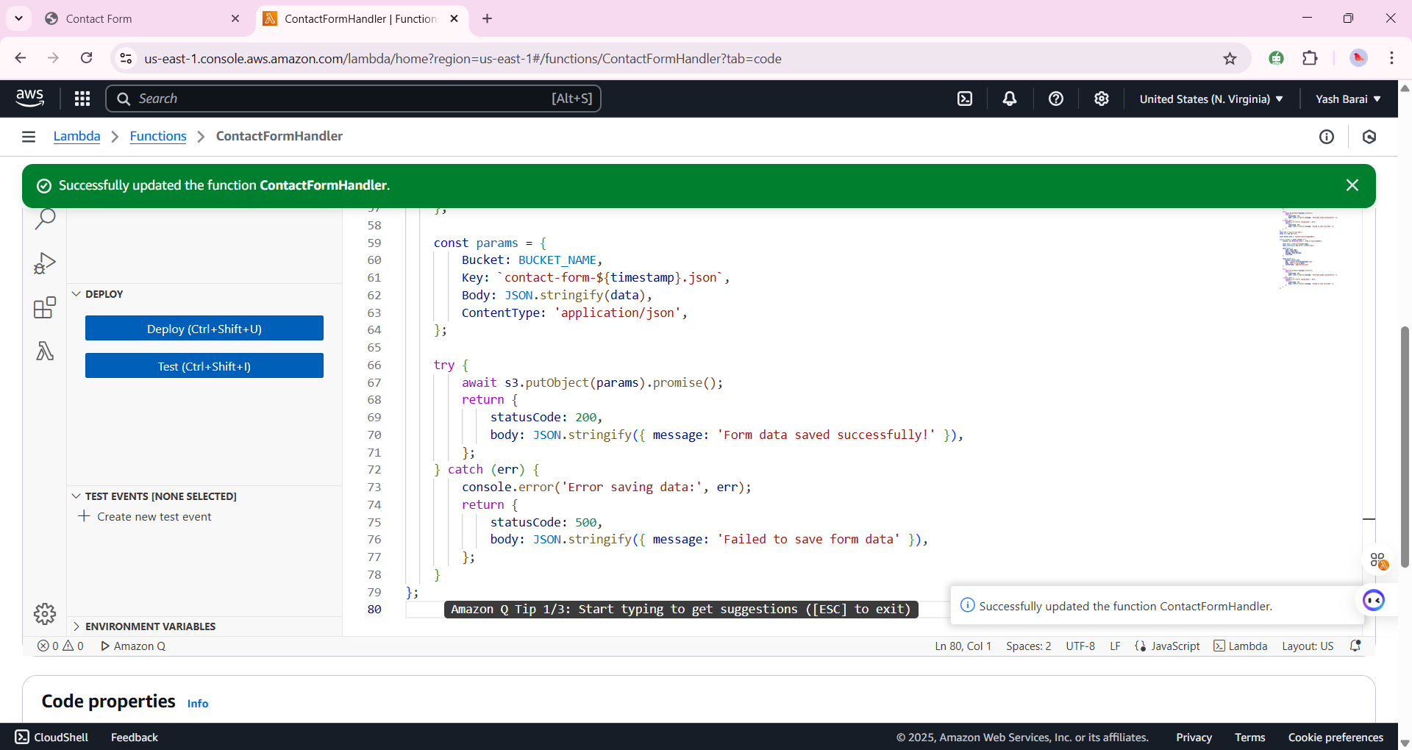
* **Step 4: Add S3 Write Permissions to Lambda**

1. Go to **IAM > Roles**
2. Select the role used by your Lambda.
3. Click **Add permissions** > Attach policy.
4. Search for and attach **AmazonS3FullAccess** or create a custom policy with just PutObject.
5. 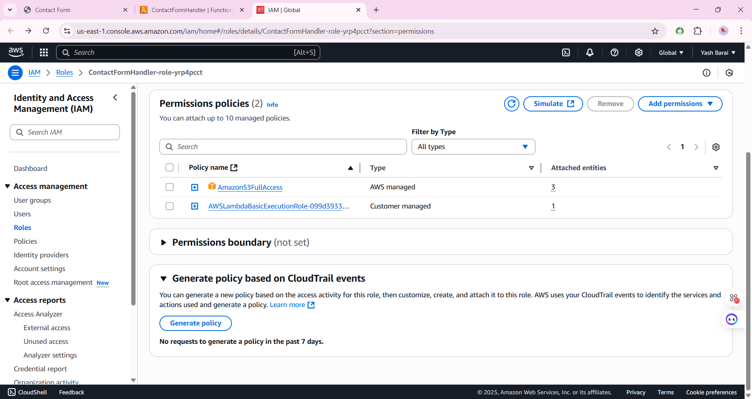
6. 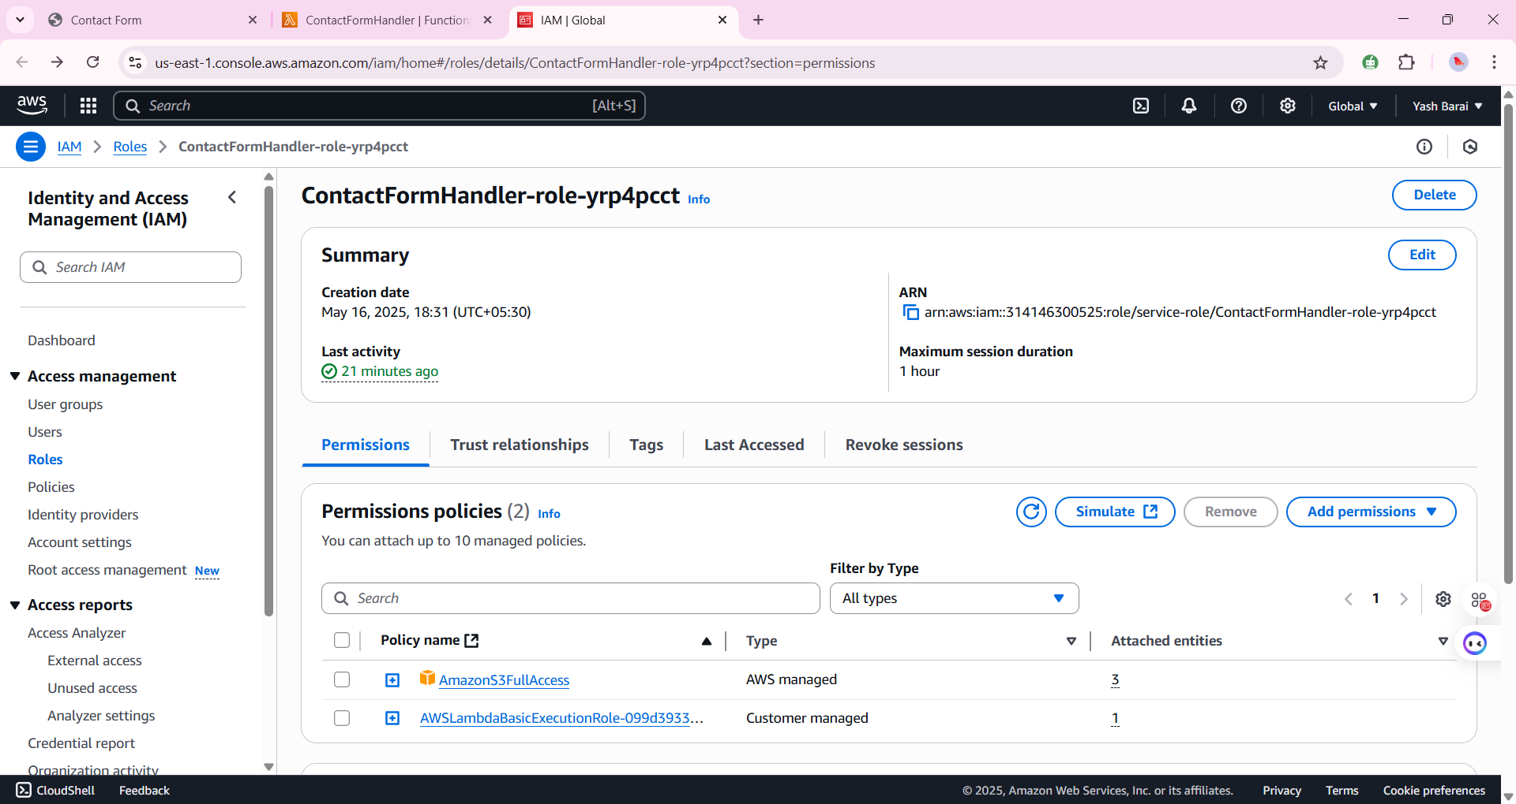

* **Step 5: Create API Gateway Endpoint**

1. Go to **API Gateway** > **HTTP API** > Create.
2. Choose **"Add Integration"** > Lambda.
3. Select your Lambda function.
4. Set route: POST /submit
5. Enable CORS (allow all origins)
6. Click **Next** > Create.

* 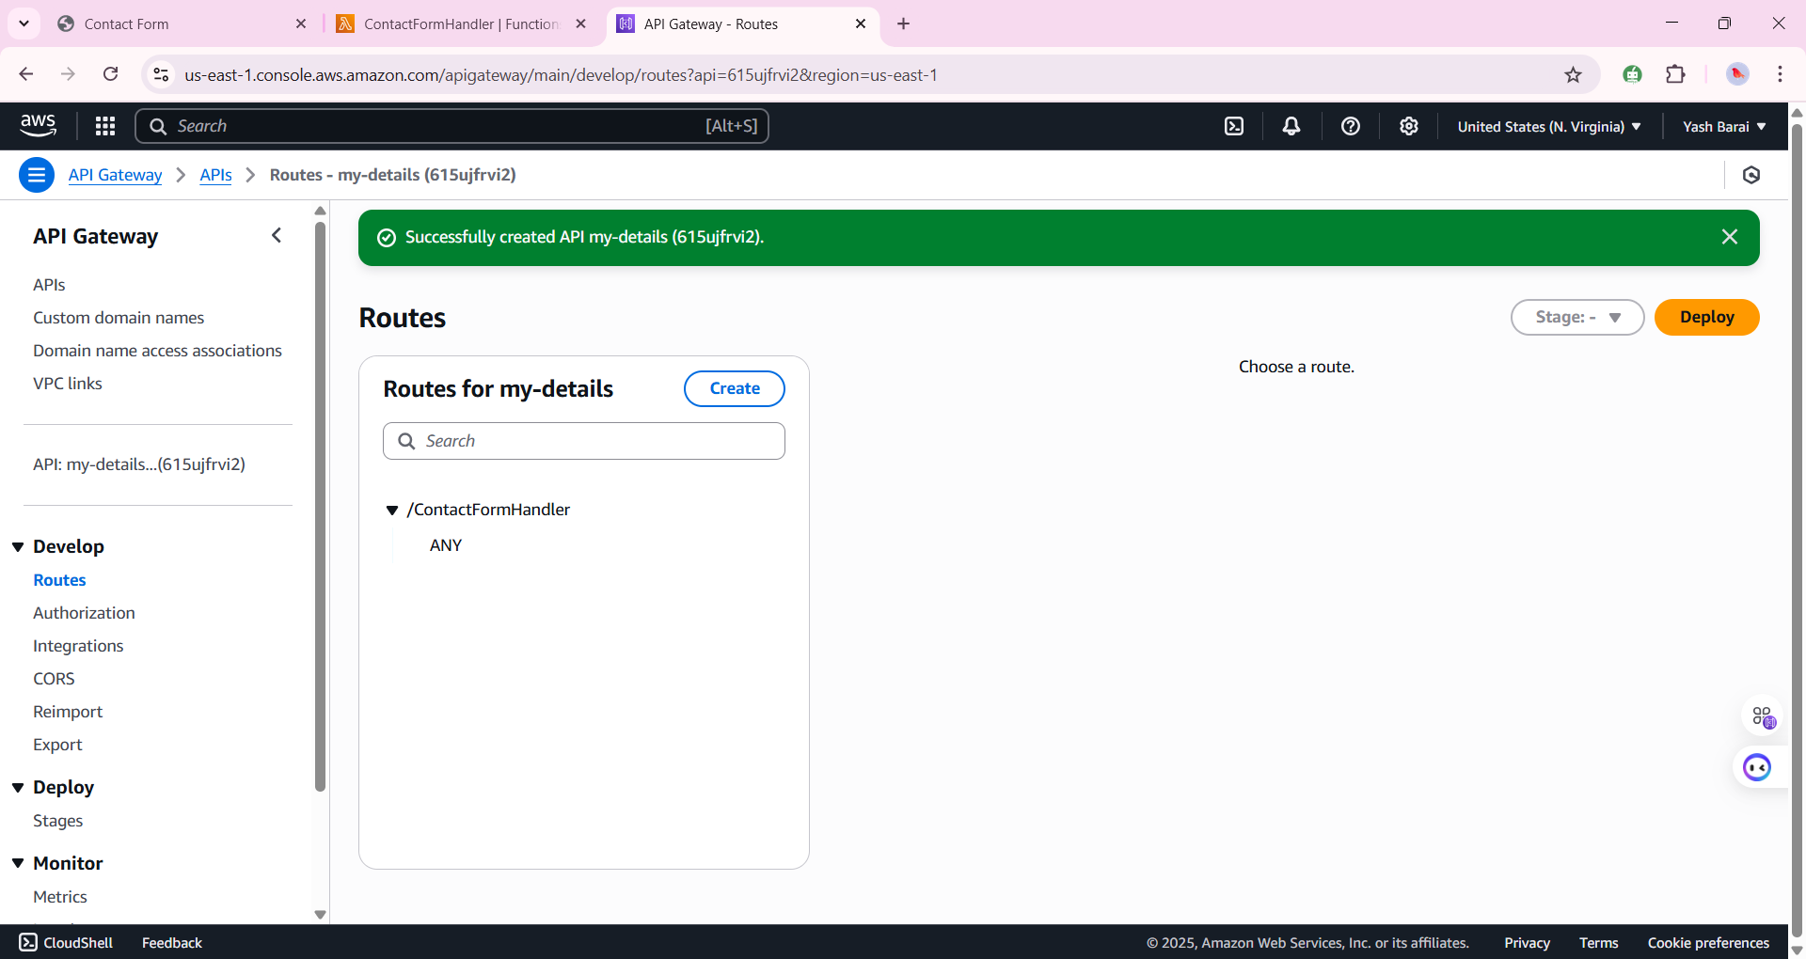
* **Step 6: Create the HTML Contact Form**
* html
* Copy code
* <!DOCTYPE html>
* <html>
* <head>
* <title>Contact Form</title>
* </head>
* <body>
* <h2>Contact Us</h2>
* <form id="contact-form">
* <input type="text" name="name" placeholder="Your Name" required /><br><br>
* <input type="email" name="email" placeholder="Your Email" required /><br><br>
* <textarea name="message" placeholder="Your Message" required></textarea><br><br>
* <button type="submit">Send</button>
* </form>
* <script>
* document.getElementById("contact-form").addEventListener("submit", async function(e) {
* e.preventDefault();
* const form = new FormData(e.target);
* const data = Object.fromEntries(form.entries());
* const response = await fetch("https://<your-api-id>.execute-api.<region>.amazonaws.com/submit", {
* method: "POST",
* headers: { "Content-Type": "application/json" },
* body: JSON.stringify(data)
* });
* const result = await response.json();
* alert(result.message);
* });
* </script>
* </body>
* </html>
* 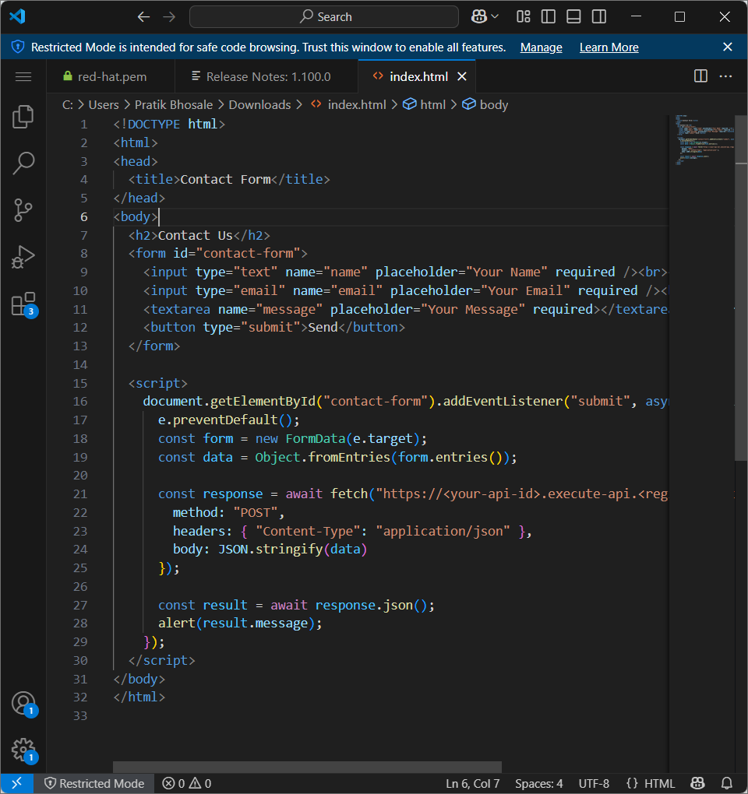
* **✅ Test It**

1. Open the HTML file in your browser.
2. Fill out the form and submit.
3. Go to S3 → Check that a .json file has been created with your form data.

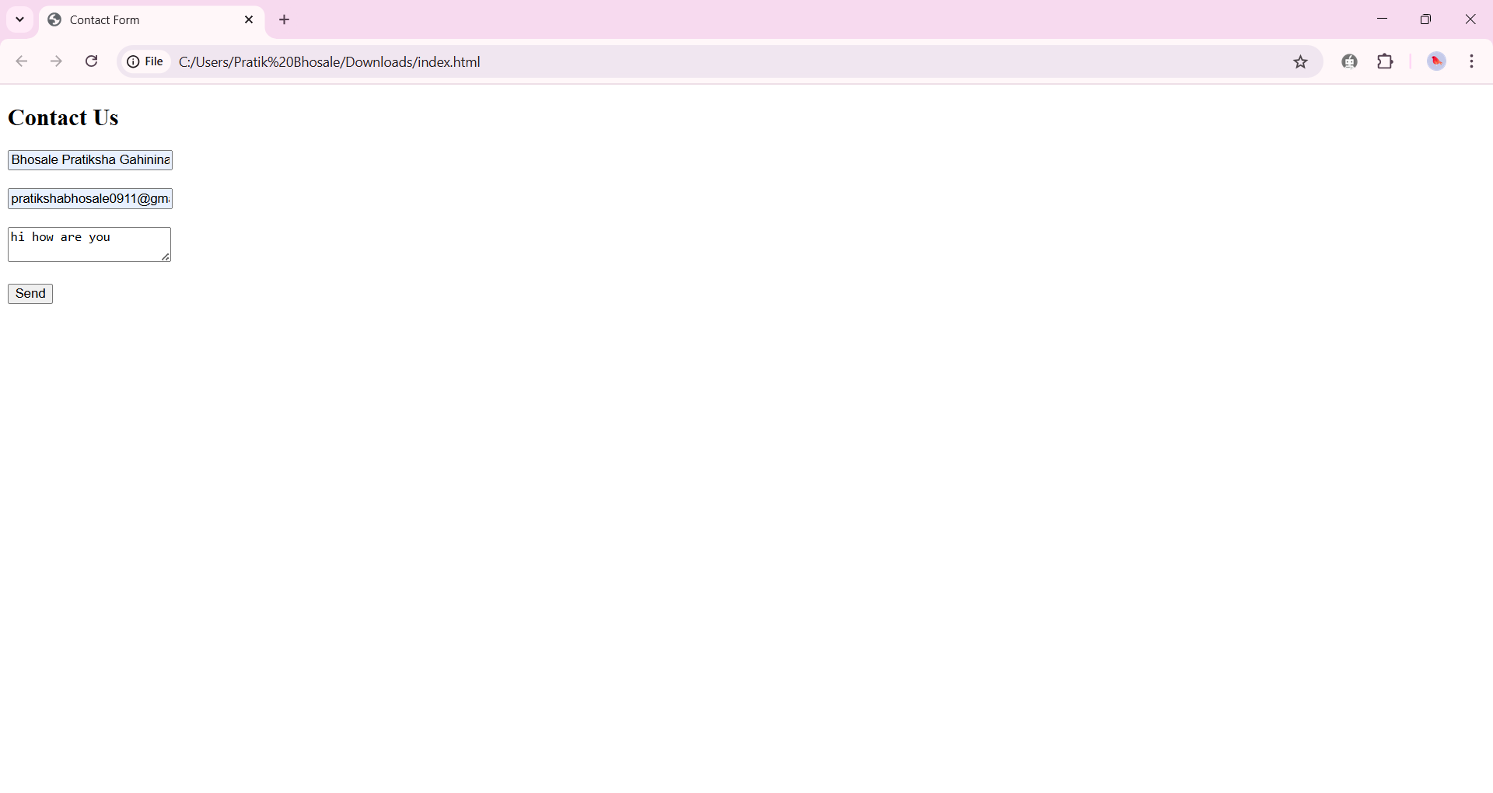

**Project 3 :Static Website Hosting on S3 + CloudFront**

* **1. Prepare the HTML File**
* Create a simple HTML file named index.html:
* html
* Copy code
* <!DOCTYPE html>
* <html>
* <head>
* <title>Welcome</title>
* </head>
* <body>
* <h1>I am Pratiksha, welcome to my website.</h1>
* </body>
* </html>
* **2. Create an S3 Bucket**
* Go to AWS S3 console.
* Click **"Create bucket"**.
* Set a globally unique name (e.g., Pratik-ssh).
* Choose your region.
* **Uncheck** "Block all public access" (for website hosting).
* Create the bucket.

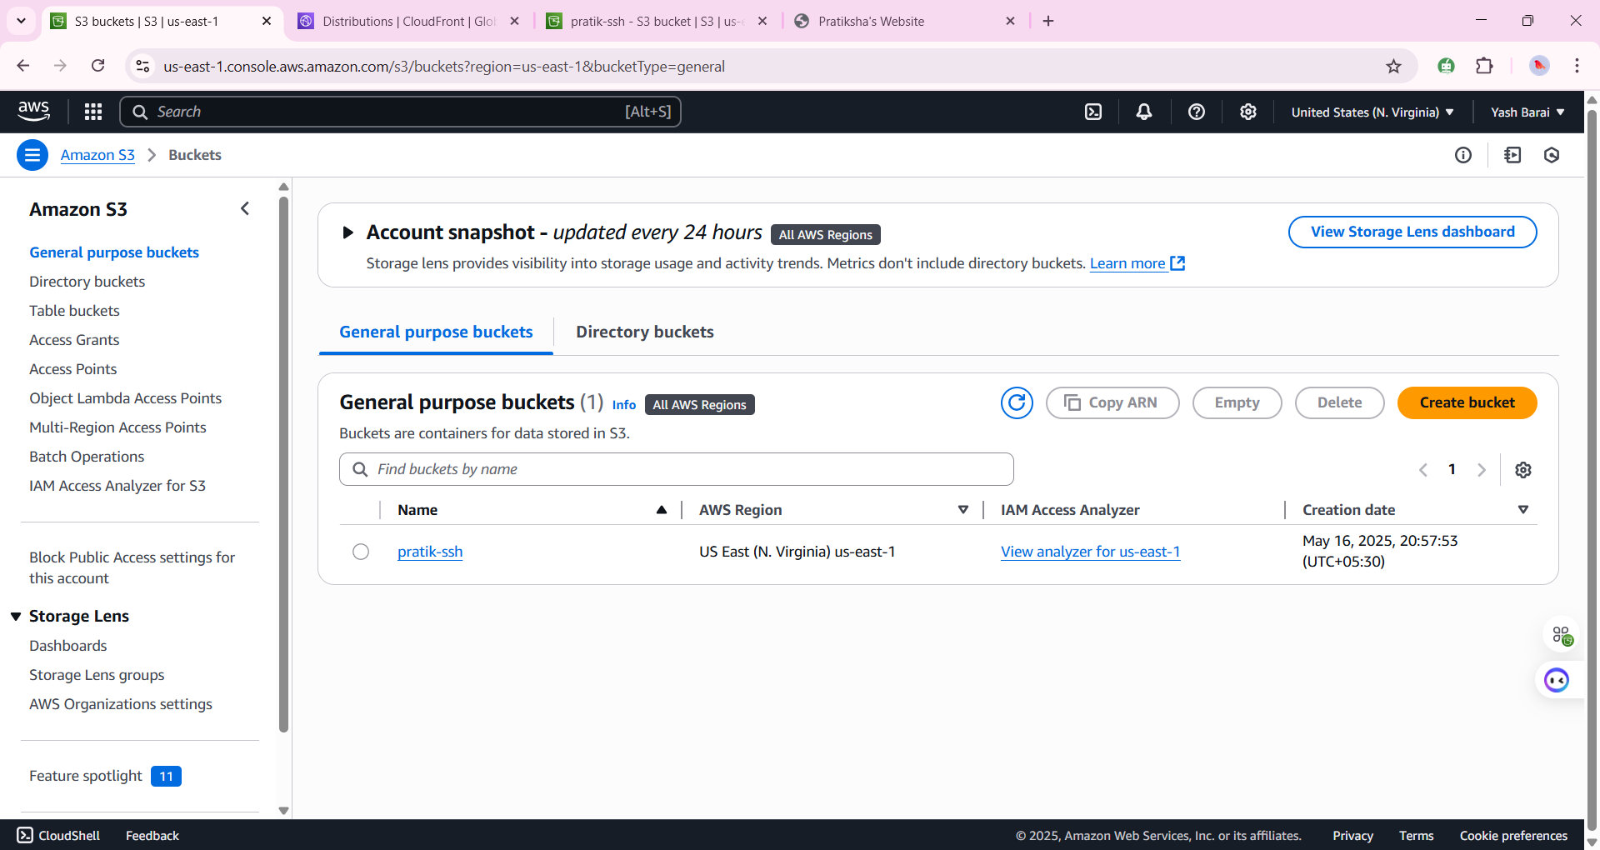

* **3. Upload Your Website Files**
* Go inside your bucket.
* Click **Upload**, and add index.html.
* Click **Upload**.
* 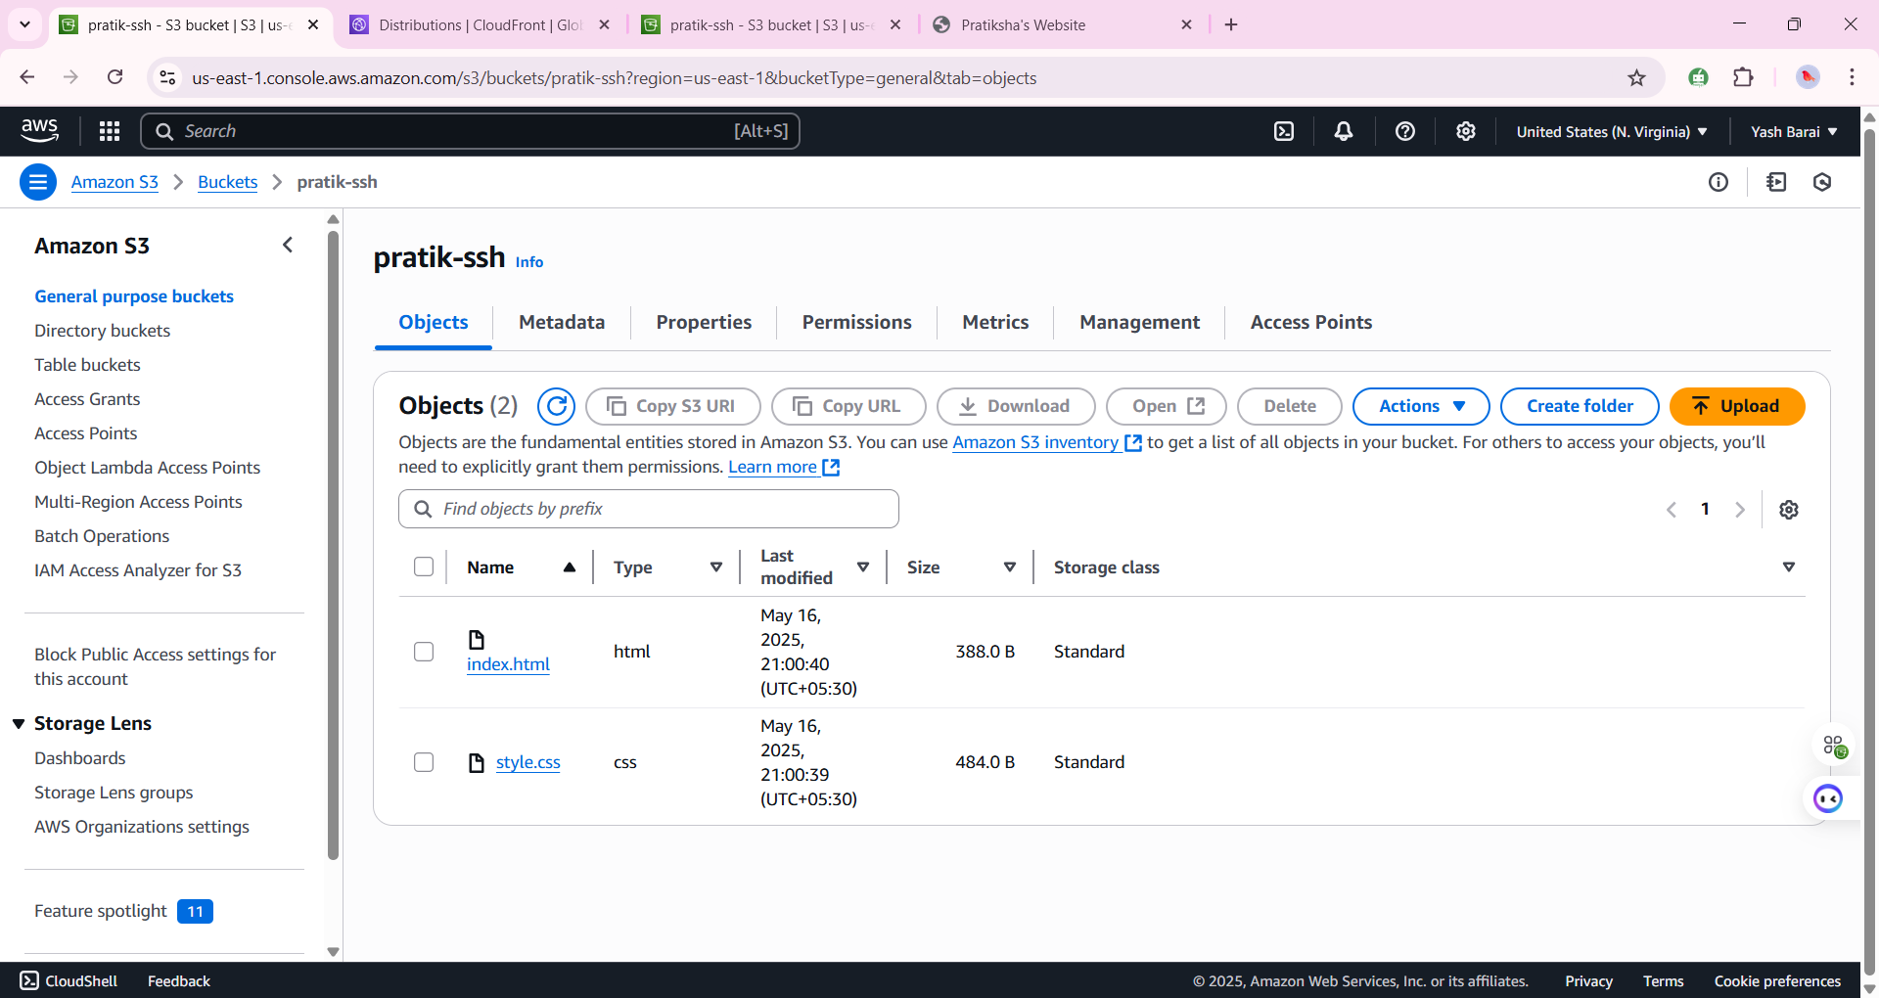
* **4. Configure Bucket for Static Website Hosting**
* Go to the bucket **Properties** tab.
* Scroll to **Static website hosting**.
* Click **Edit**.
* Enable it.
* Set:
  + **Index document** = index.html
* Save changes.
* 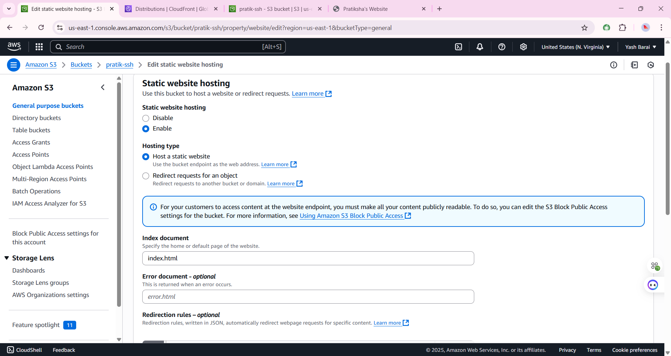
* **5. Make Your Bucket Public**
* **A. Set Bucket Policy**
* Go to the **Permissions** tab → **Bucket policy**, and paste:
* json
* Copy code
* {
* "Version": "2012-10-17",
* "Statement": [
* {
* "Sid": "PublicReadForWebsite",
* "Effect": "Allow",
* "Principal": "*",
* "Action": "s3:GetObject",
* "Resource": "arn:aws:s3:::pratiksha-ssh/*"
* }
* ]
* }
* 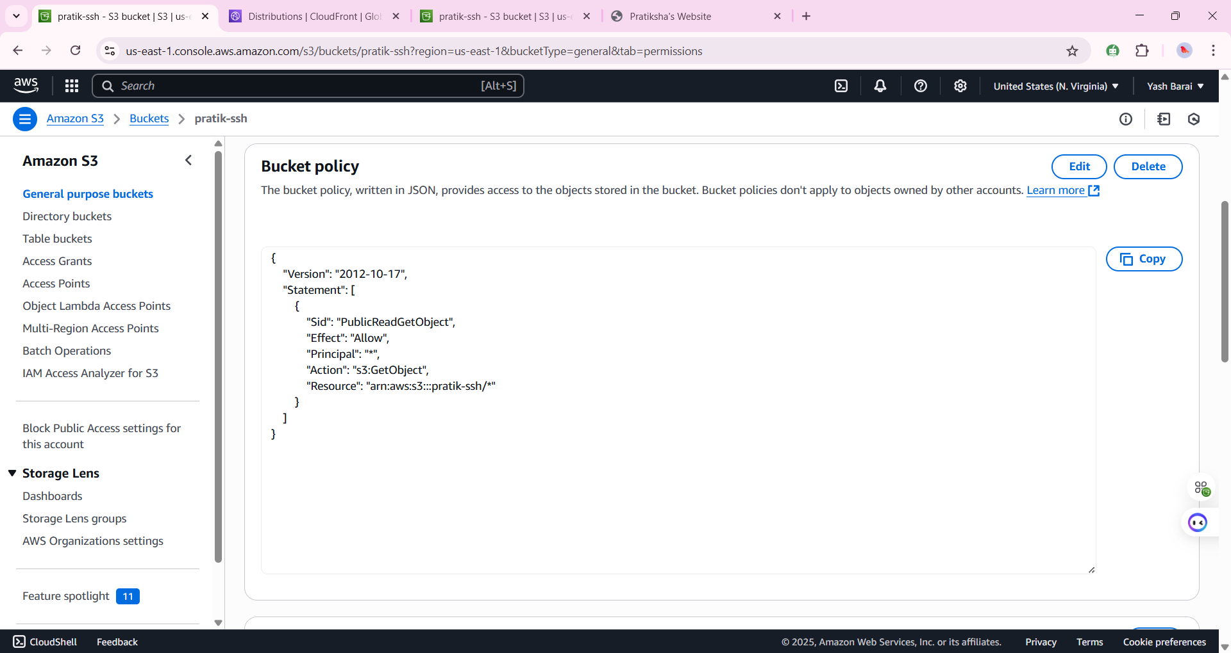
* **6. Access Your Website**
* Go back to **Static website hosting** section in **Properties**.
* Copy the **Endpoint URL** and open in browser.
* ✅ You should see:  
  **"I am Pratiksha, welcome to my website."**
* 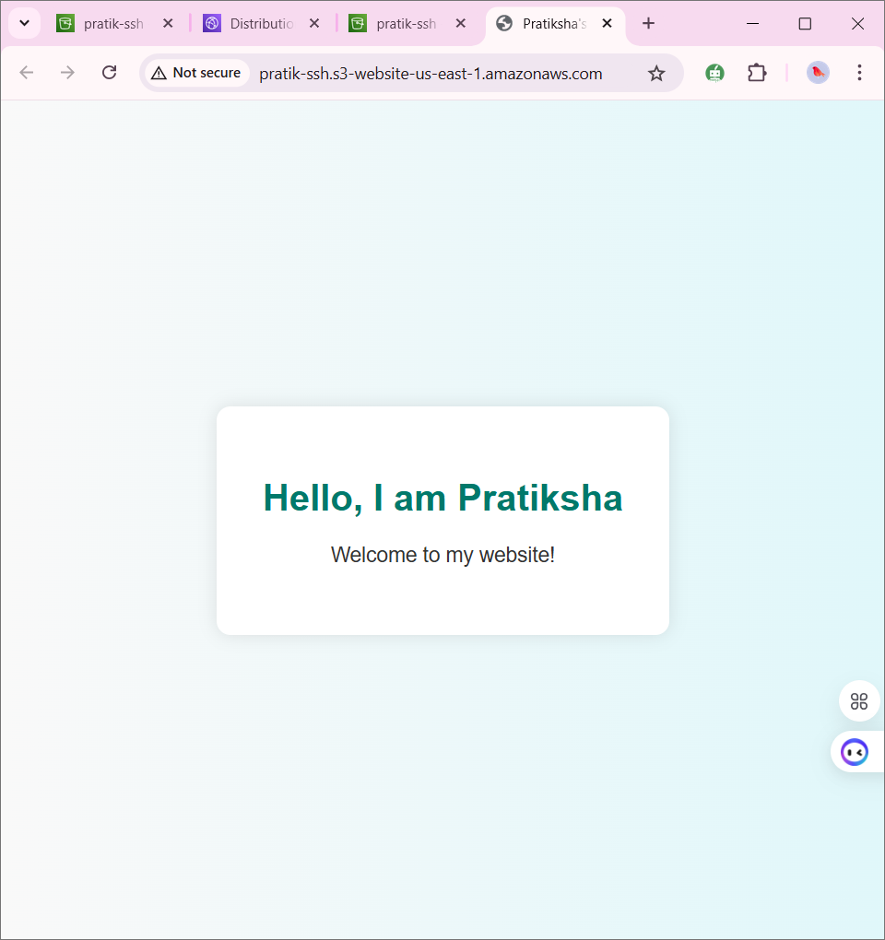

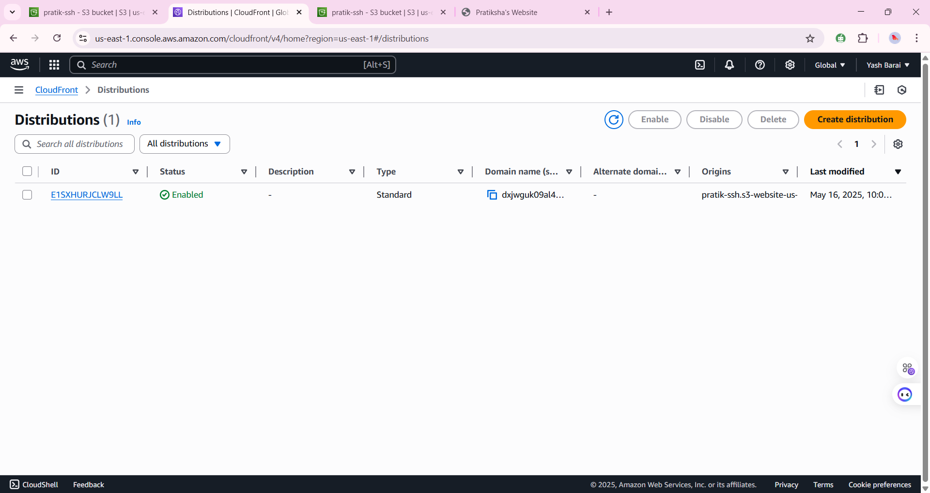

* **Project 4: Ansible-based NGINX Web Server Automation on AWS EC2**
* **1. Provision an EC2 Instance on AWS**
* **Instance Type:** t2.micro (for free tier)
* **AMI:** Red Hat Enterprise Linux (RHEL)
* **Security Group:** Allow SSH (port 22) and HTTP (port 80)
* **Key Pair:** Create or use an existing .pem key
* ssh -i ~/aws-key.pem ec2-user@ 172.31.18.122
* 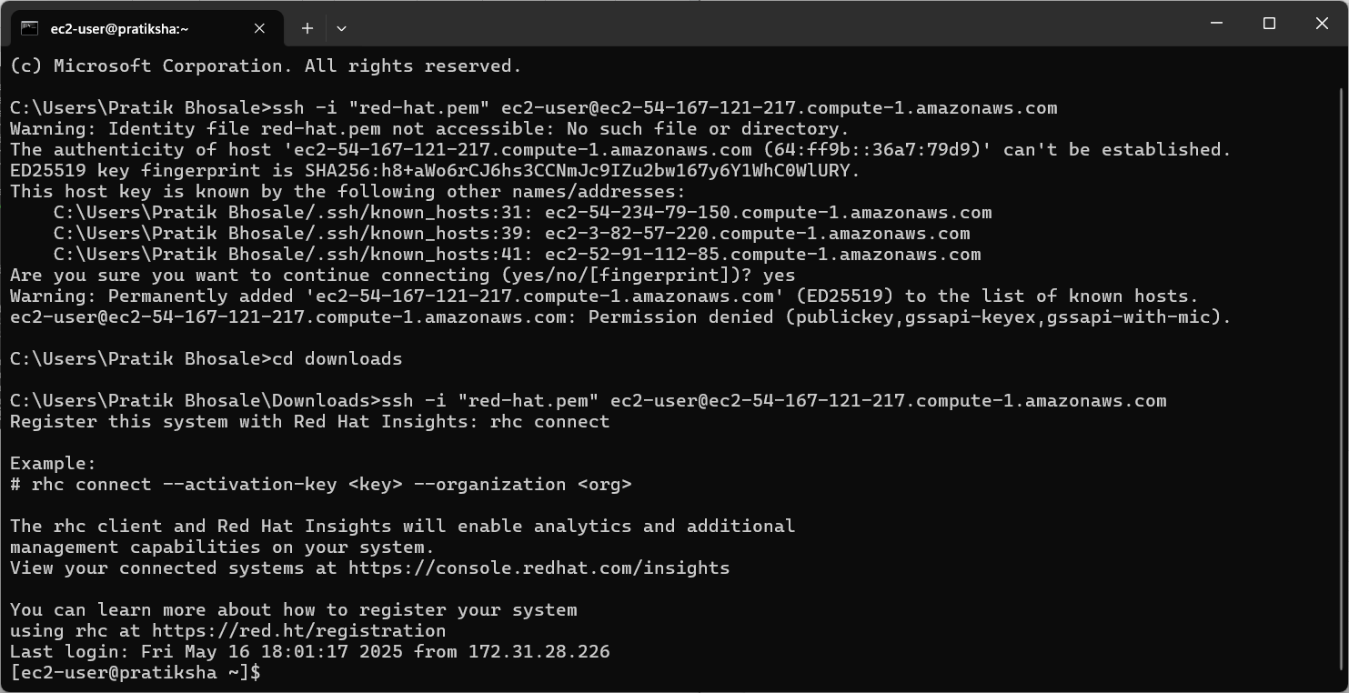
* 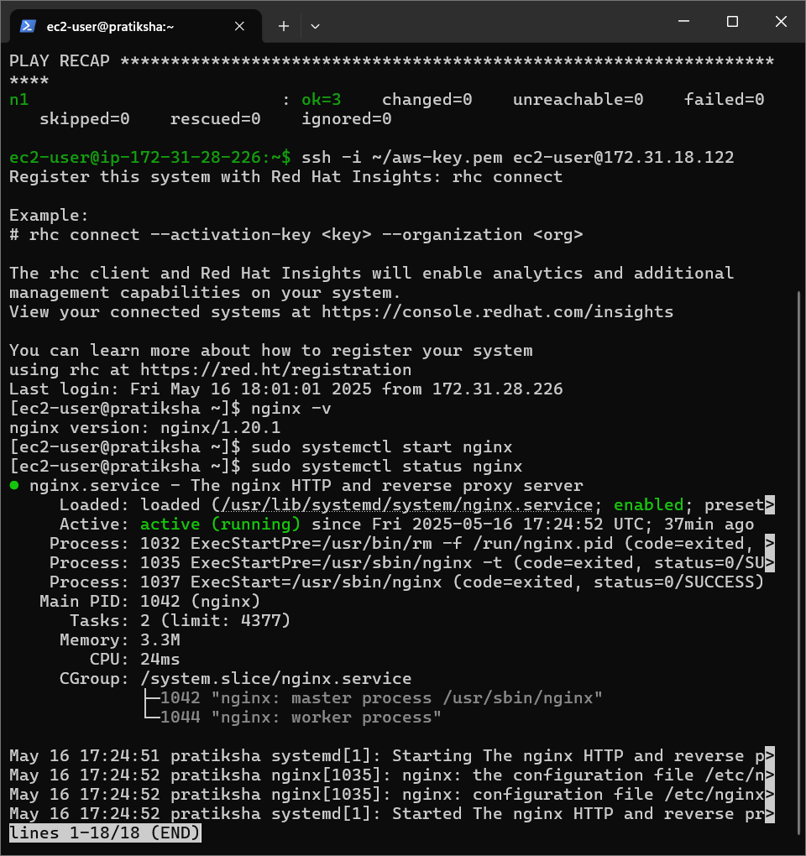

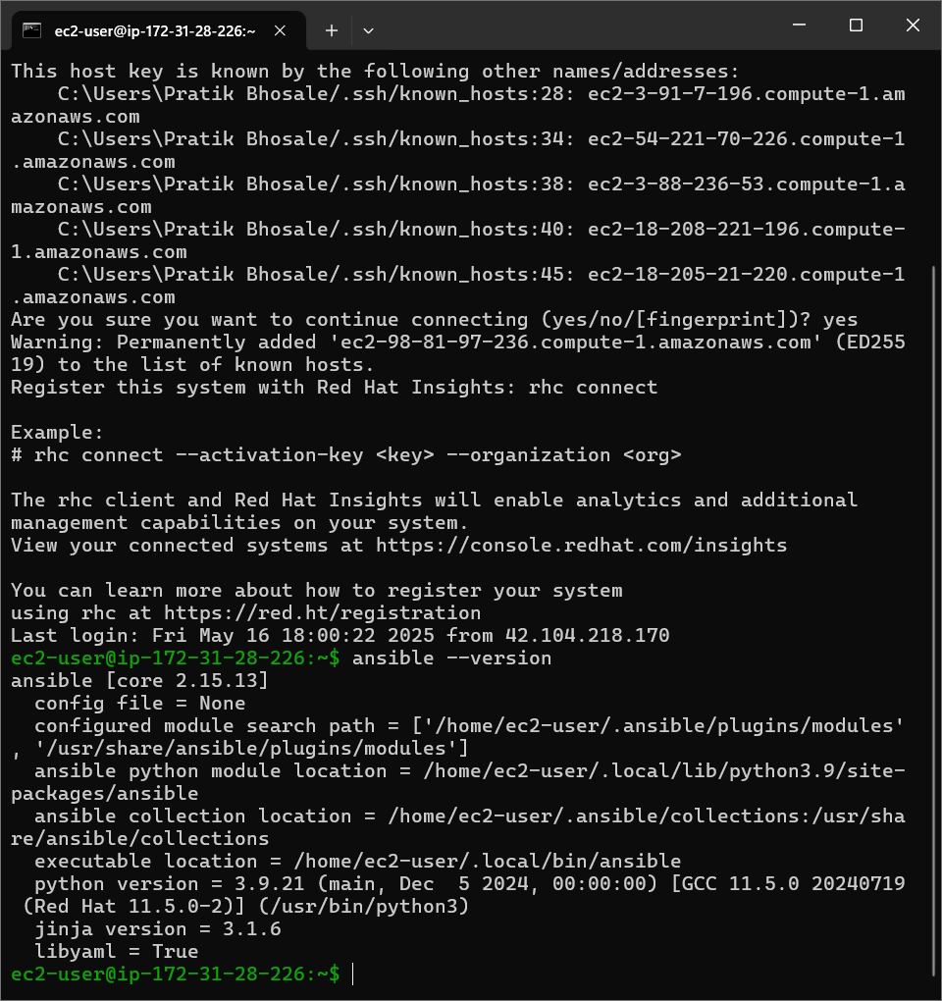

Install ansible on ansible on master node

Sudo ansible



2. Set Up Inventory File

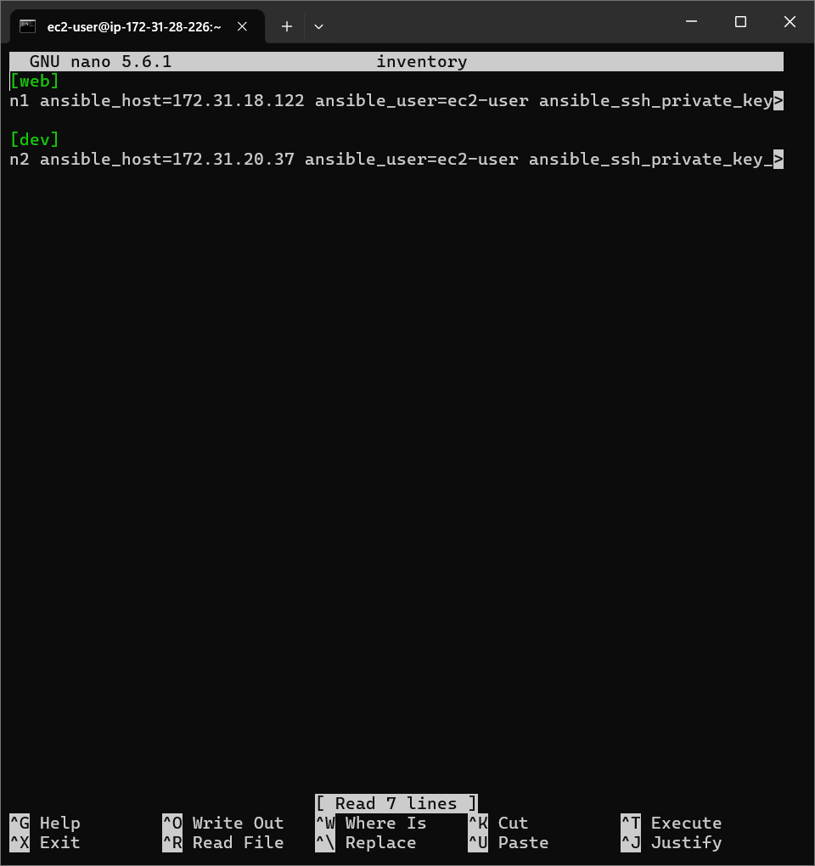

Commands : vi na.yml

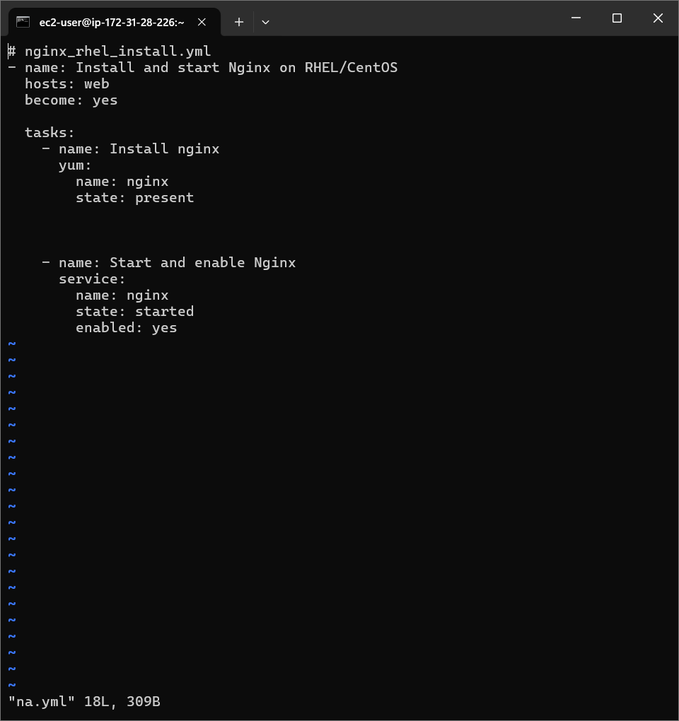

Command: ansible-playbook -I inventory na.yml

* 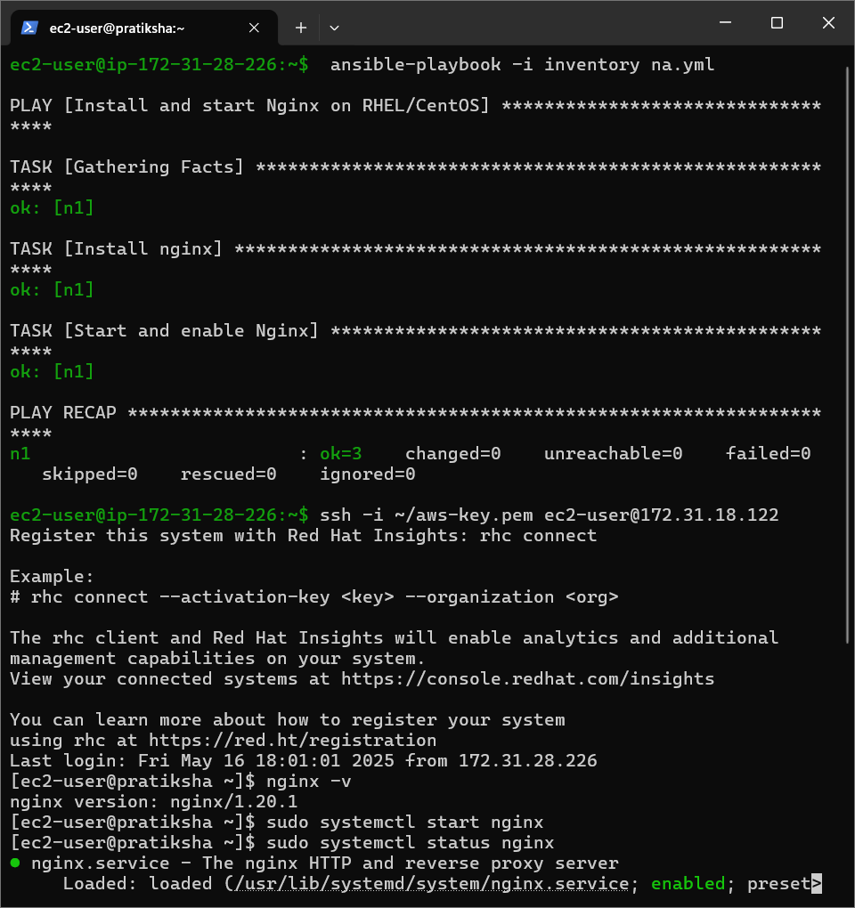

Check the service on salve node: sudo systemctl status

* 

After that ensure you stop the ec2 instance

Project 5 :EC2 + S3 Integration Skills Used: EC2, S3, IAM

Obj: Create an EC2 instance that downloads or uploads files to S3. guide for this Assign an IAM Role to EC2 with S3 access policy (no need to use access keys).

Step 1: Create an S3 Bucket

1. Go to the S3 service in the AWS Console.

2. Click "Create bucket".

3. Enter a unique name (e.g., my-ec2-s3-integration-bucket).

4. Choose a region (same as EC2).

5. Optional: Uncheck "Block all public access" if needed.

* 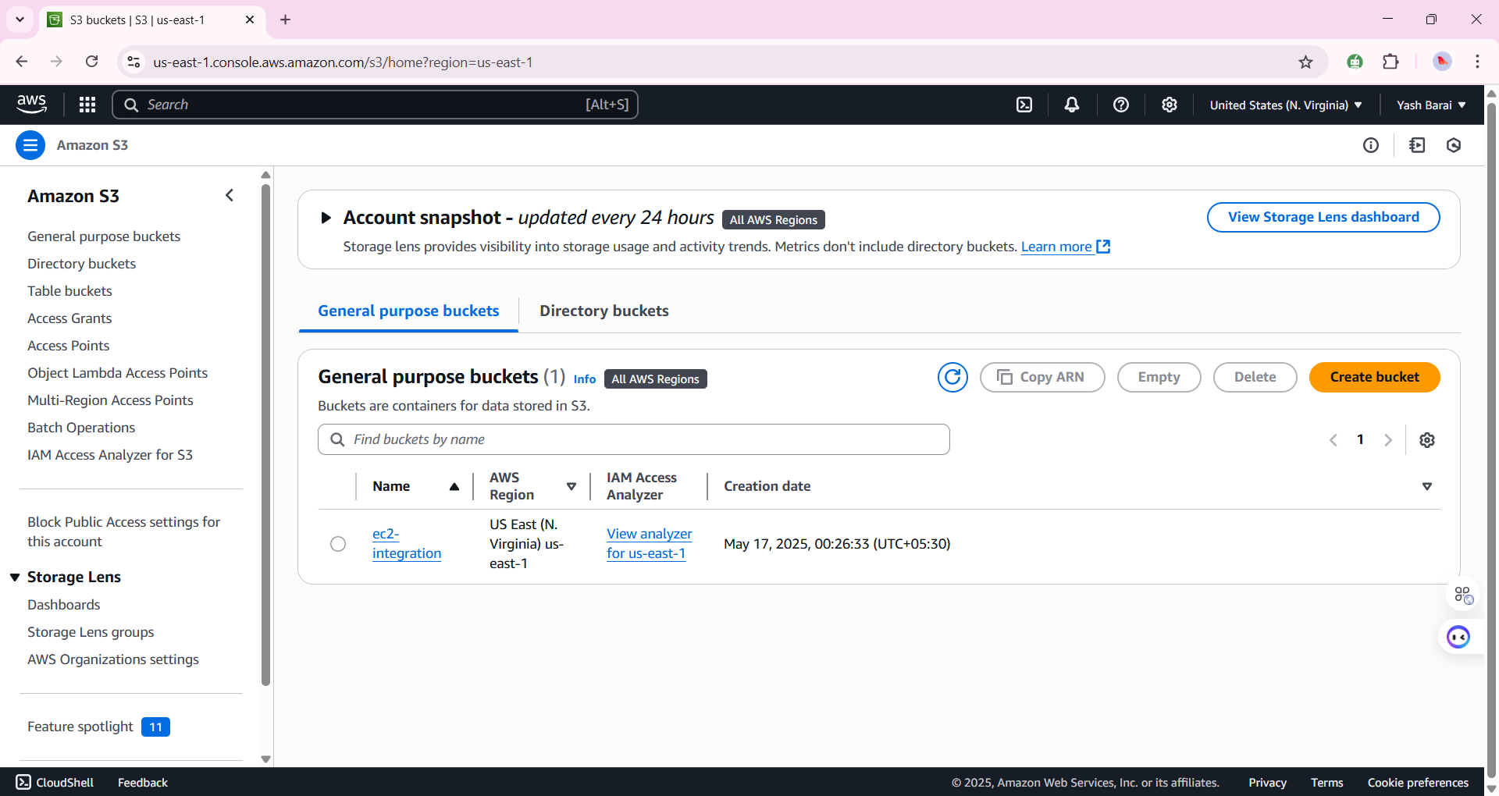

1. Click "Create bucket".

Step 2: Create an IAM Role with S3 Access

1. Go to IAM -> Roles -> Create Role.

2. Choose 'AWS service' as trusted entity, then 'EC2'.

3. Attach 'AmazonS3FullAccess' policy.

4. Name it (e.g., EC2-S3-Access-Role).

5. Click 'Create Role'.

* 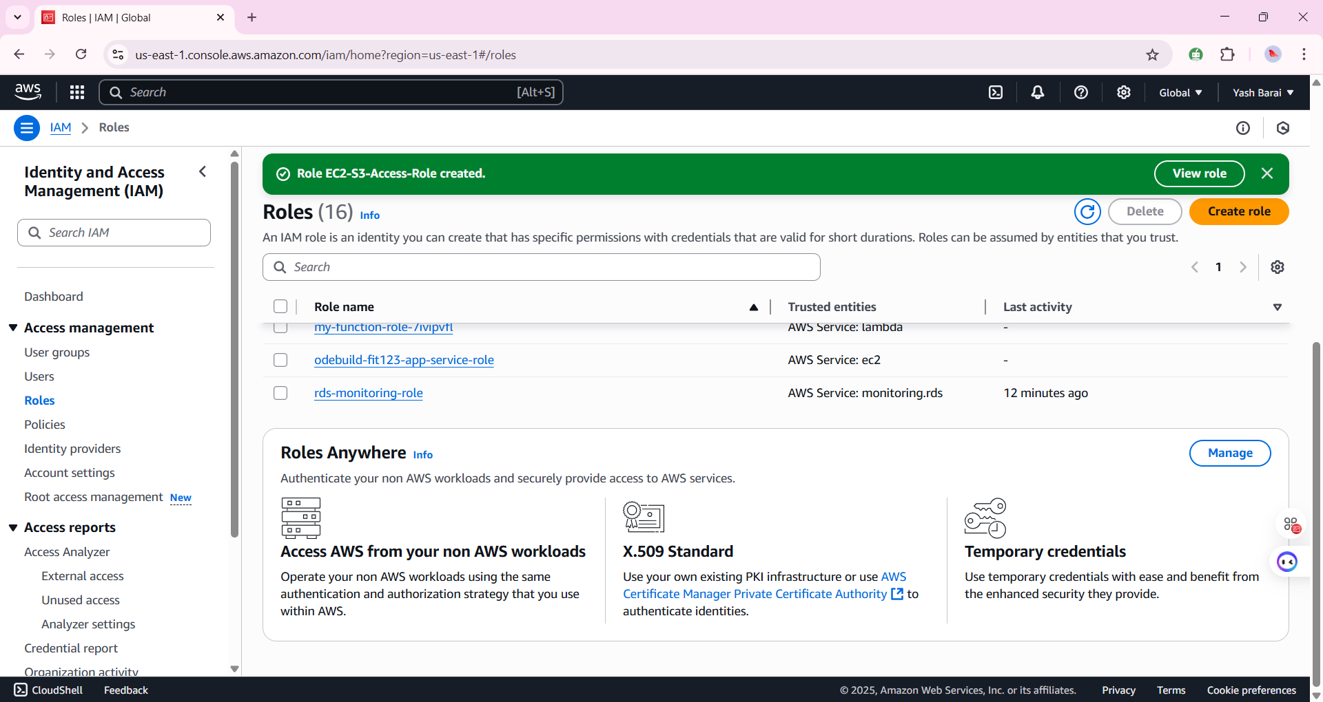

Step 3: Launch EC2 Instance

1. Go to EC2 -> Launch Instance.

2. Choose Ubuntu

3. Select t2.micro instance type.

4. Under Advanced Details -> IAM Role, choose EC2-S3-Access-Role.

5. Launch instance.

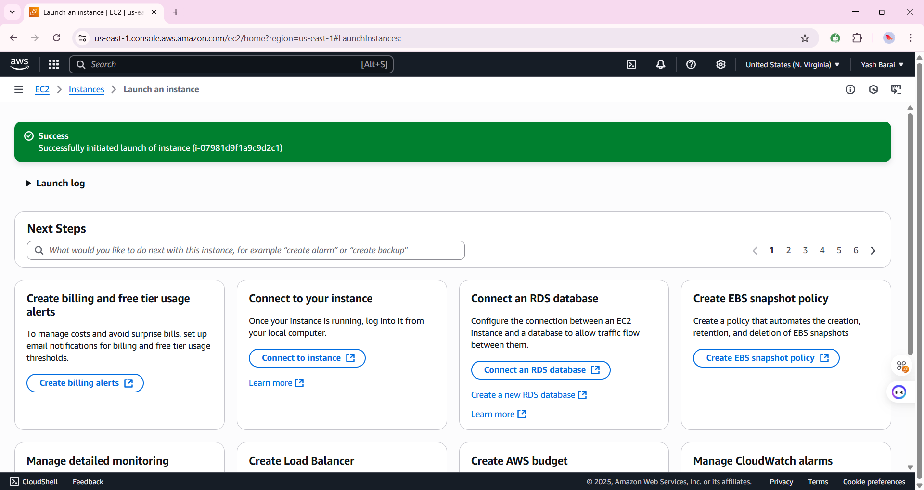

Step 4: Connect to EC2 & Set Up AWS CLI

ssh -i "red-hat.pem" [ubuntu@ec2-18-234-78-60.compute-1.amazonaws.com](mailto:ubuntu@ec2-18-234-78-60.compute-1.amazonaws.com)

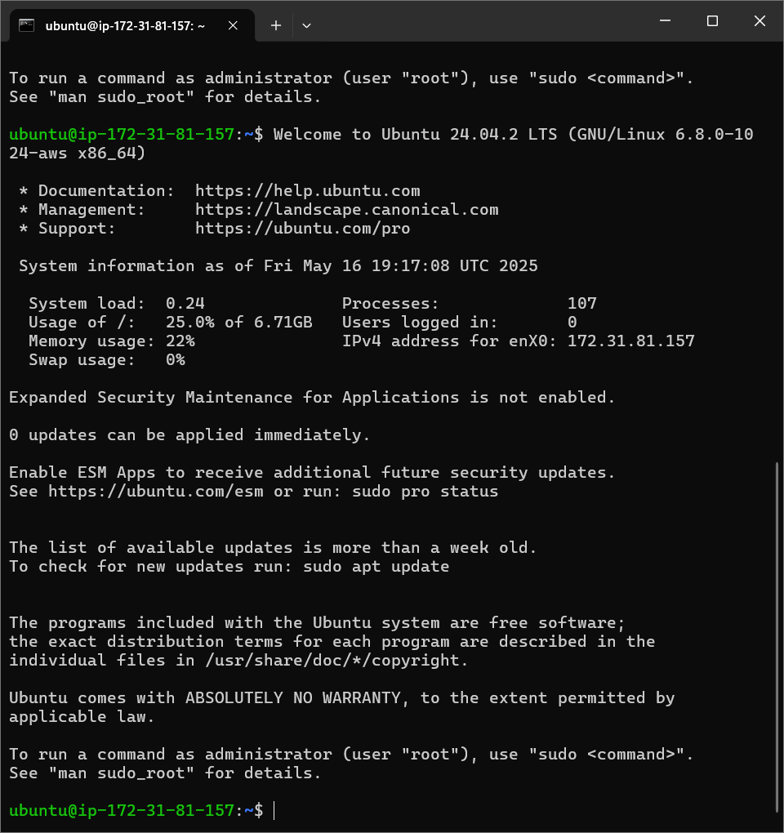

Step 5: Upload & Download Files via AWS CLI

EC2 + S3 Integration via IAM Role (No Access Keys) Output

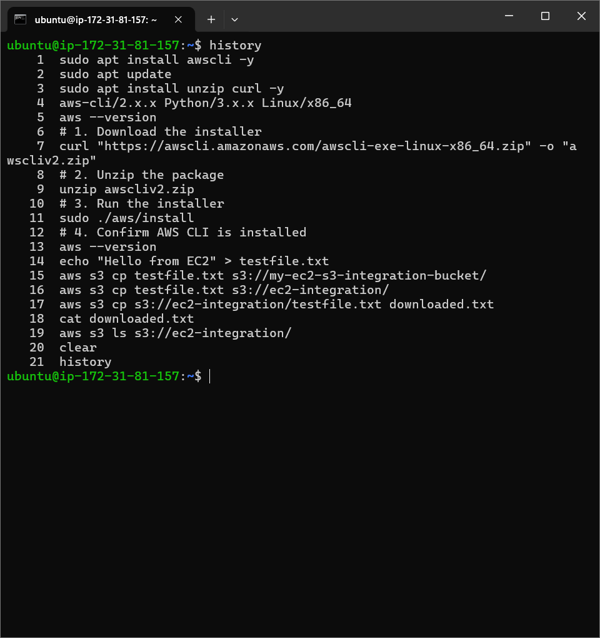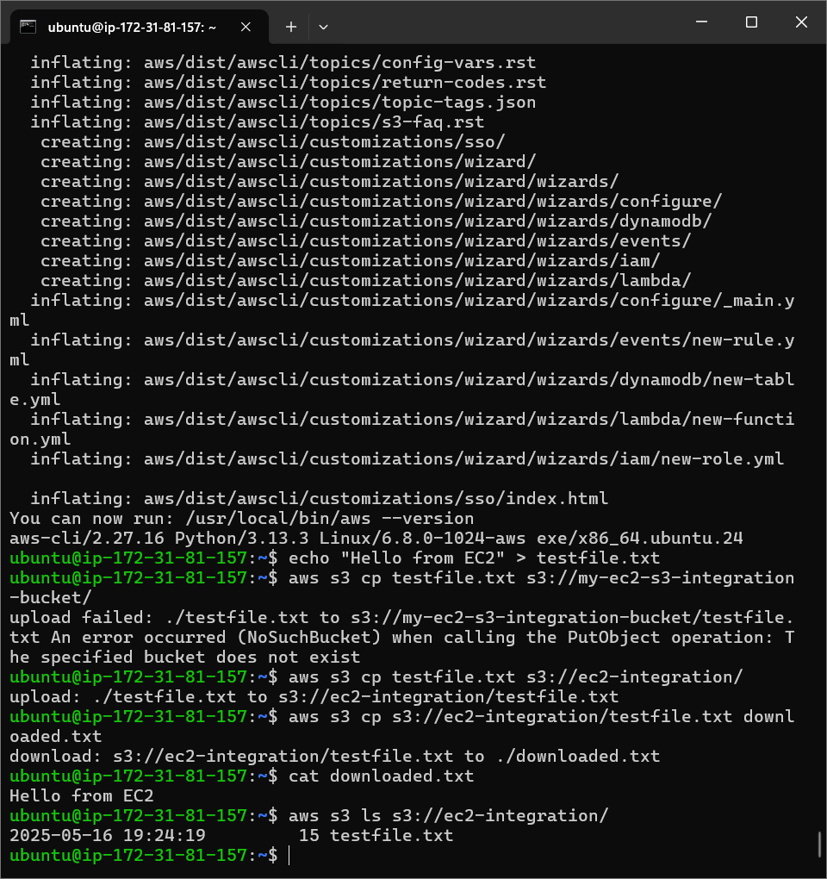

Command to rmove file from s3

aws s3 rm s3://ec2-integration/testfile.txt

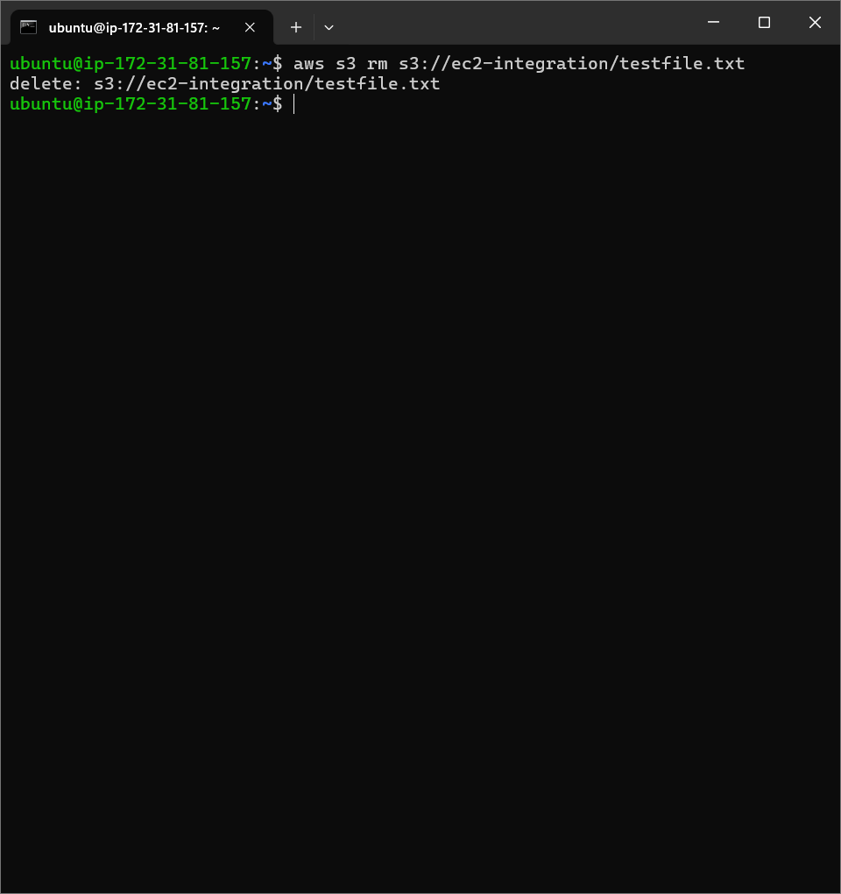

Stop and terminate instance after work done

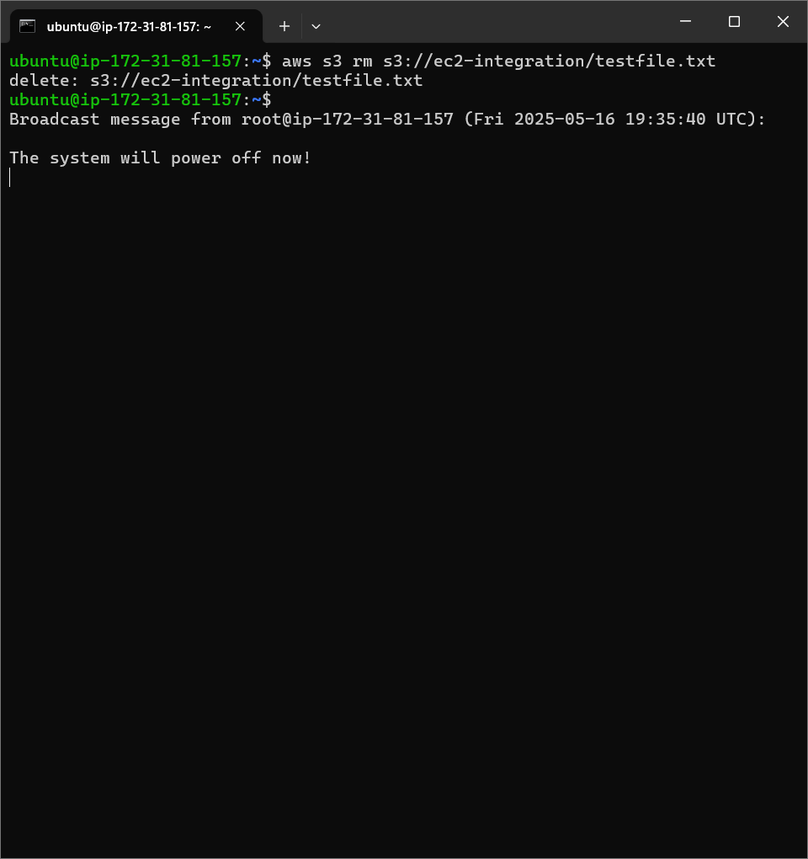

Project 6 . Scheduled File Cleanup using Lambda

* **Objective:**
* Automatically delete old files (e.g., older than 30 days) from an S3 bucket using a Lambda function triggered on a schedule.

Step 1: Create an S3 Bucket

1. Go to **S3 Console**.
2. Click **"Create bucket"**, give it a unique name.
3. Note the bucket name — you'll need it in your Lambda code.
4. 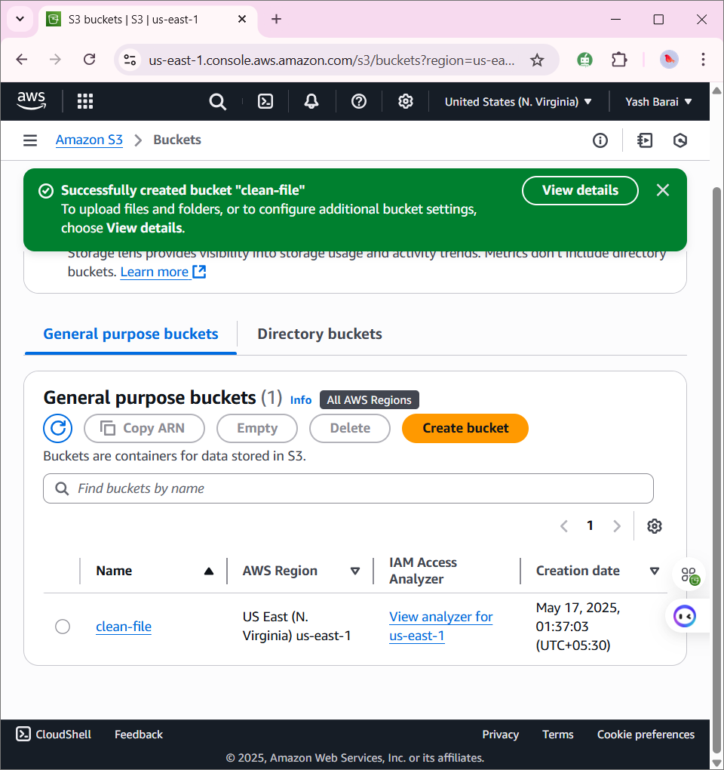

* **Step 2: Create an IAM Role for Lambda**

1. Go to **IAM Console** → **Roles** → **Create Role**.
2. Choose **Lambda** as the trusted entity.
3. Attach the following policies:
   * AmazonS3FullAccess (or create a custom policy with s3:ListBucket, s3:DeleteObject)
   * CloudWatchLogsFullAccess
4. Name the role (e.g., LambdaS3CleanupRole) and create it.

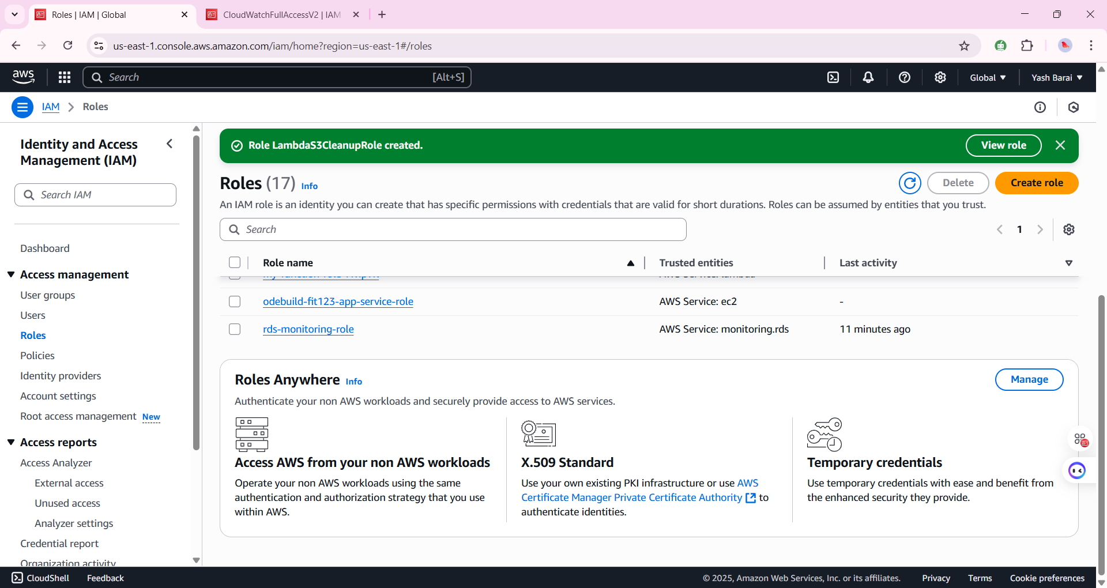

* **Step 3: Create the Lambda Function**

1. Go to **Lambda Console** → **Create Function**.
2. Choose **Author from scratch**.
   * Name: S3CleanupFunction
   * Runtime: **Python 3.11**
   * Role: Use the IAM role you created earlier.
3. Use this example **Python code** (deletes files older than 30 days):

Lambda function:

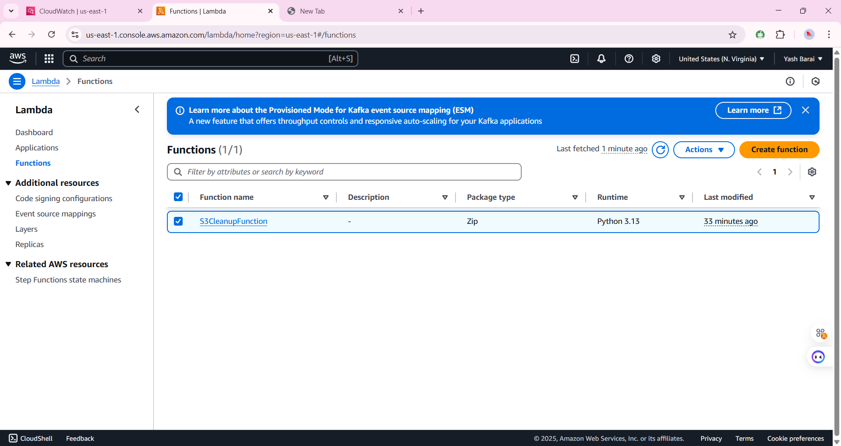

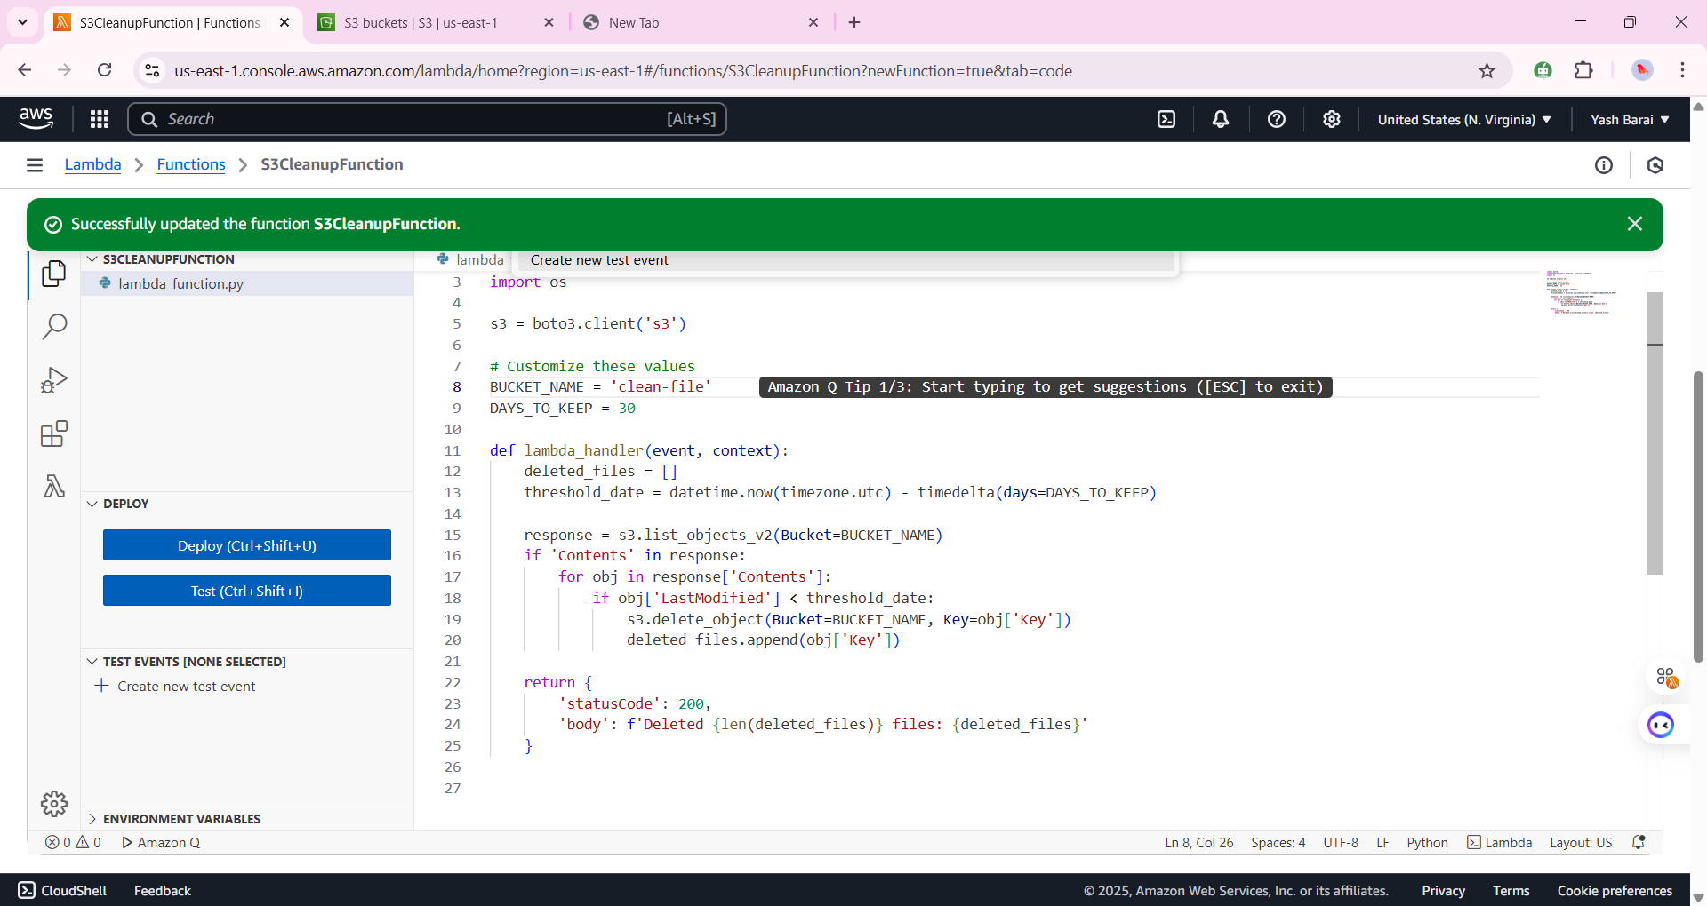

**5: Set Up CloudWatch Event Rule (Scheduled Trigger)**

1. Go to **Amazon EventBridge** (or CloudWatch → Rules).
2. Click **Create Rule**.
3. Under **Event Source**, choose:
   * **Schedule** → use cron or rate expression (e.g., rate(1 day)).
4. Under **Target**, select:
   * **Lambda Function** → Choose your S3CleanupFunction.
5. Enable the rule.

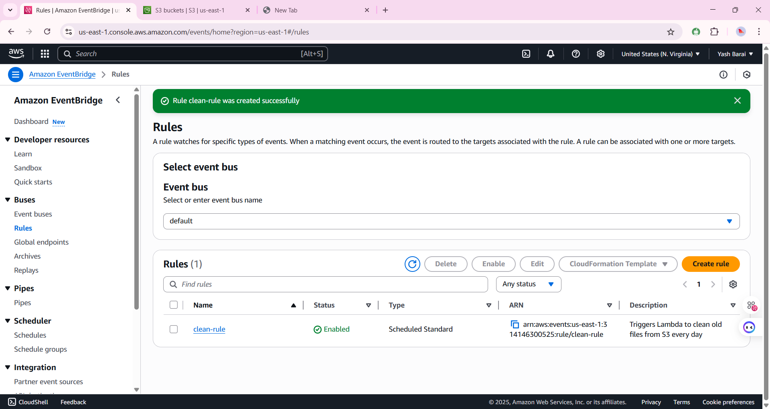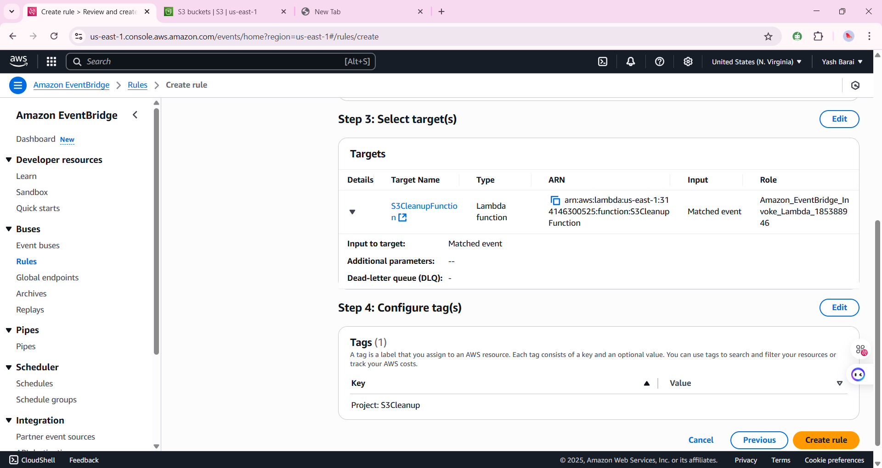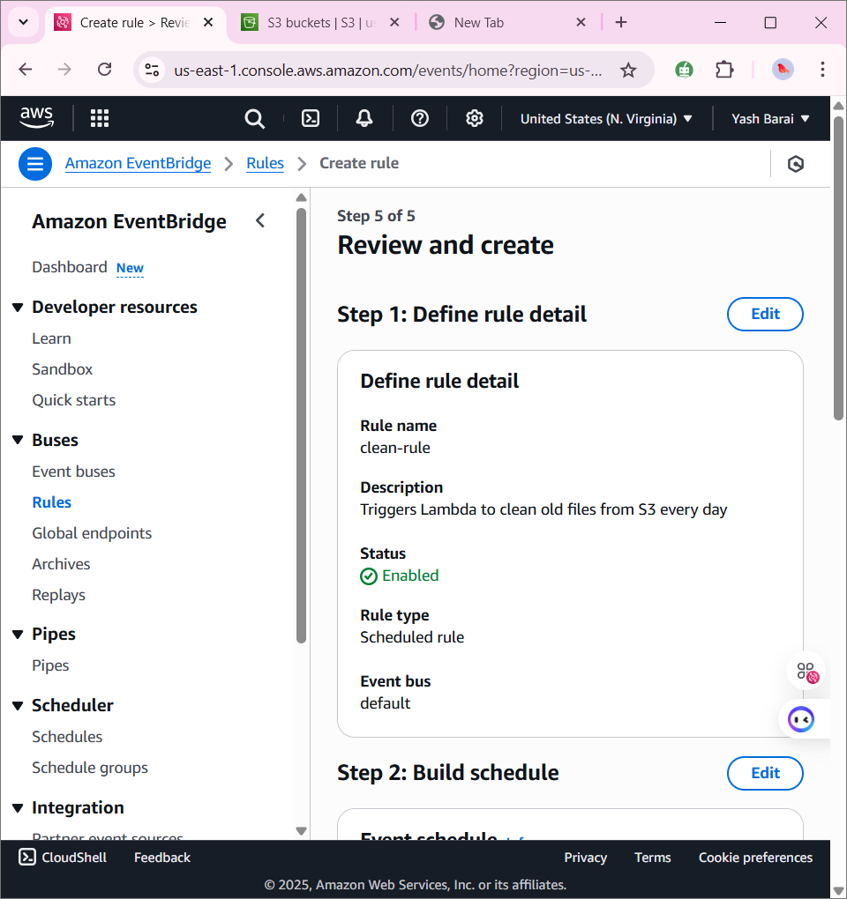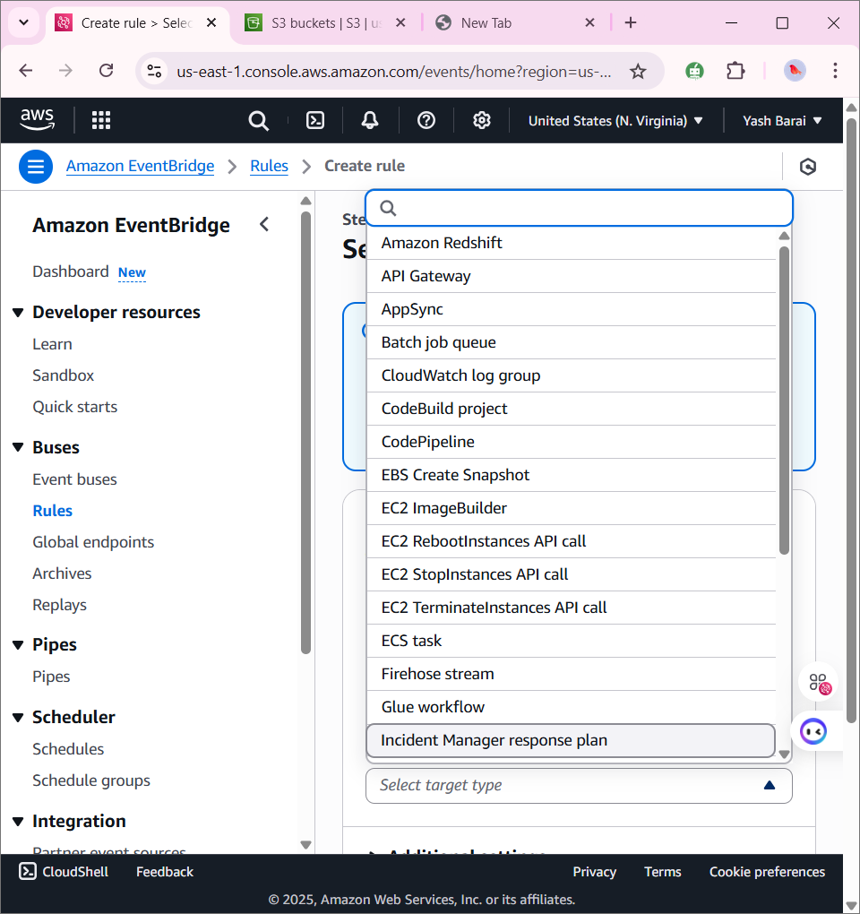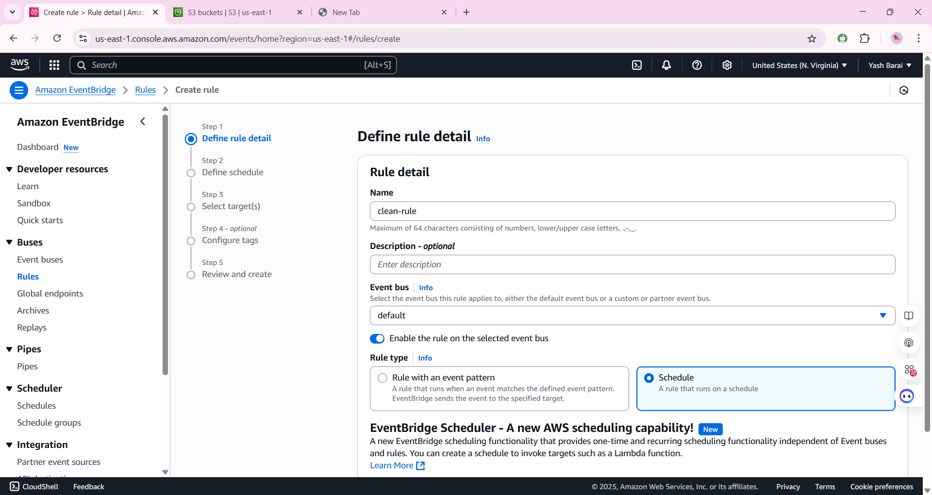

After 30 days it will automatically delete the files from s3